KINGHUNT No.39
By Vern Stannard
Try and tactically visualise white’s next move as you go through the following solutions on your computer.

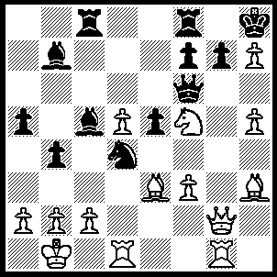
1.Bg5 Qb6 (1…..Qxf5, 2Bxf5 Nxf5, 3.Qg4 f6, 4.Qxf5 fxg5, 5.Qxg5 Rf7, 6.Qxe5 b3, [6…..Re7, 7.Qg5 R(c)f8 [[7…..Bxg2, 8.Qxe7 Bc5, 9.Qxb7 IF 7.R(c)e8, 8.d6 Bxd6 ------{{8…..Bxg2, 9.dxe7 Bb6, 10.h6 gxh6, 11.Qf6+ Kxh7, 12.Qf7+ Kh8, 13.Rd6 Be3, 14.Rg6}}--- 9.Rxd6 Bc8 , 10.Rd8 Rxd8, 11.Qxe7 Rd7, 12.Qe8+ Kxh7, 13.Qxc8]], 8.h6 g6, 9.d6 Re6, 10.Qxc5 R(e)f6, 11.Rxg6 Rxg6, 12.d7 Rd8, 13.Qe5+ Kxh7, 14.Qe7+ Kh8, 15.Qxd8+ Rg8, 16.Qxg8+], 7.axb3 Re7, 8.Qf5 Bxg1, 9.d6 Re2 [9…..Bc5, 10.dxe7 Bxe7, 11.Qf7], 1-0.Rxg1 R(c)e8, 11.Qf7 Re1+, 12.Rxe1 Rxe1+, 13.Ka2 Kxh7, 14.Qxb7), 2.Bh6 g6 (2…..Rg8, 3.Bxg7+ Kh7, 4.d6 Qxd6 [4…..Bxf3/Bxd6, 5.Qxg6+ fxg6, 6.hxg6++], 5.Nxd6 b3 [5…..Bxf3, 6.Qg5 Rh8 [[6…..Nf5, 7.Bxf5++]], 7.Qh6+ Kg8, 8.Qxh8++], 6.Rxd4 Be4 [6…..Bxd4, 7.Bf5++], 7.Qg5 bxc2+ Kc1, Rh8, 9.Qh6+ Kg8, 10.Qh8++), 3.Bg7+ Kxh7, 4.d6 Kg8 (4…..Rh8, 5.hxg6+ Kg8 [5…..fxg6, 6.Qxg6 Kg8, 7.Ne7++], 6.gxf7+ Kxf7, 7.Qg6+ Kg8, 8.Ne7++ OR 4…..Bxf3, hxg6+ Kg8 [5…..fxg6, 6.Qxg6+ Kg8, 7.Bf6++], 6.gxf7+ Kxf7 [6…..Rxf7, 7.Nh6+ Kh7, 8.Qg6++], 7.Qg6+ Kg8, 8.Bxe5++ OR 4…..Nxf5, 5.hxg6+ Kg8 [5…..Kxg7, 6.gxf7+ Kxf7, 7.Qg6++], 6.gxf7+ Kxf7 [6…..Rxf7, 7.Bf6+ Ng7 [[7…..Rg7, 8.Qxg7+ Nxg7, 9.Be6+ Kh7, 10.Rxg7+ Kh6, 11.Rh1++]], 8.Qxg7+ Rxg7, 9.Be6+ Kh7 [[9…..Kh8, 10.Rh1++]], 10.Rxg7+ Kh6, 11.Rh1++], 7.Qg6+ Kg8, 8.Bxf8+ Kxf8, 9.Qg8++ OR 4…..Qxd6, 5.Rxd4 Kg8 [5…..Qe6, 6.Qg5 Kg8, 7.Qh6 f6, 8.hxg6 Qxa2+, 9.Kxa2 Bd5+, 10.Ka1 Bxd4, 11.Qh8++IF 5…..Bxd4, 6.Qg5 Be3, 7.hxg6+ Qxg6, 8.Qh4+ Bh6, 9.Rxg6 fxg6, 10.Qxh6+ Kg8, 11.Ne7+ Kf7, 12.Qxg6+ Kxe7. 13.Qe6+ Kd8, 14.Qd7++ IF 5…..Qxd4, 6.hxg6+ Kg8, 7.gxf7+ Rxf7 [[7…..Kxf7, 8.Qg6+ Kg8, 9.Bf6++], 8.Nh6+ Kh7, 9.Qg6++], 6.Rxd6 Be4, 7.Rxg6 fxg6 [7…..Bxc2+, 8.Qxc2 e4 [[8..….f6, 9.Bxf6+ Kf7 {{9…..Kh7, 10.Rh6++}}, 10.Qb3+ Ke8, 11.Ng7++ IF 8…..fxg6, 9.Nh6+ Kxg7, 10.Qxg6+ Kh8, 11.Qg7++]], 9.Rh6 f6, 10.Qb3+ Rf7, 11.Rh8++], 8.Qxg6 Bxc2+, 9.Ka1 Bxf5, 10.Bxf5 Rxf5, 11.Bf6+ Kf8, 12.Qg8++), 5.hxg6 f6 (5.....fxg6, 6.Ne7+ Kxg7, 7.Qxg6+ Kh8, 8.Qh6++ OR 5…..Bd5, 6.gxf7+ Rxf7, 7.Bxe5+ Kh7, 8.Qg6++ OR 5…..Bxf3, 6.gxf7+ Kxf7 [6…..Rxf7, 7.Nh6+ Kh7, 8.Qg6++], 7.Qg6++),6.Qg4 Bd5, 7.Qh5 Bxa2+, 8.Kxa2 b3+, 9.Ka1 Nxc2+, 10.Kb1 Na3+, 11.bxa3 Bxg1, 12.Qh8++.

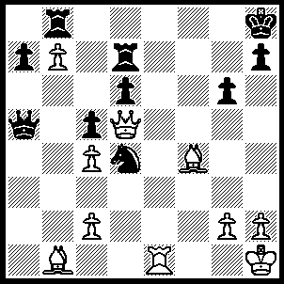
1.Be5+ Rg7 (1…..dxe5, 2.Qxe5+ Kg8 [2…..Rg7, 3.Qxb8+ Rg7, 4.Qe5+ Rg7, 6.b8(Q)+ Qd8, 7.Qxd8++], 3.Qxb8+ Rd8, 4.Rd8+ Rxe8 [4…..Kf7, 5.Qxd8], 5.Qxe8+ Kg7, 6.b8(Q)), 2.Bxg7+ Kxg7, 3.Re7+ Kh6, 4.Qe4 Nf5, 5.Qf4+ Kh5 (5…..g5, 6.Qf5), 6.Rxh7+ Nh6, 7.Rxh6++.
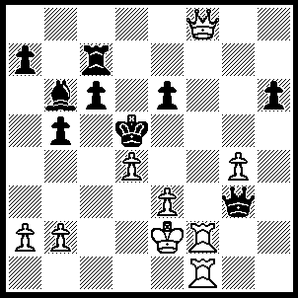
1.Rf5+ exf5 (1….Ke4, 2.Re5+ Qxe5,. 3.Qf3++ OR 1…..Kc4, 2.Rc1++), 2.Rxf5+ Kc4 (2…..Qe5, 3.Rxe5+ Kc4, 4.Qa3 Bxd4, 5.Qb3++ OR 2…..Ke6, 3.Qe8+ Kd6 [3…..Re7, 4.Qxc6+ Qd6, 5.d5++], 4.Rf6+ Kd5, 5.Qe6++), 3.Qg8+ Rf7, 4.Qxf7+ Kb4, 5.Qb3+ Ka5, 6.Qa3++.

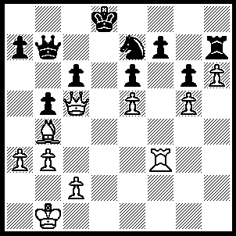
1.Qd6+ Qd7 (1…..Ke8, 2.Rd3 Nd5, 3.Qf8+ Kd7, 4.Qe7+ Kc8, 5.Qe8+ Kc7, 6.Ba5+ Nb6, 7.Qd8++), 2.Qb8+ Nc8 (2…..Qc8, 3.Bxe7+ Kd7 [3…..Kxe7, 4.Qxc8 Rxh6, 5.Rd3 Rh1+, 6.Kb2 b4, 7.Qd8++], 4.Rd3+ Kxe7, 5.Qxc8 f5, 6.Rd7++), 3.Ba5+ Ke7, 4.Rd3 Qxd3 (4…..Qe8, 5.Bb4+ Nd6, 6.Qxd6++), 5.cxd3 Nb6, 6.Bb4+ Kd7, 7.Qb7+ Kd8 (7…..Ke8, 8.Qe7++), 8.Be7+ Ke8, 9.Bf6 Kf8, 10.Qe7+ Kg8, 11.Qd8++.

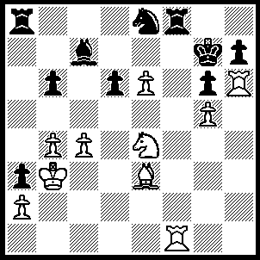
1.Bd4+ Rf6 (1…..Kg8, 2.Rxh7 Rf6 [2…..Kxh7, 3.Rh1+ Kg8, 4.Rh8++ IF 2…..Nf6, 3.Bxf6 Rxf6, 4.Nxf6+ Kf8, 5.Rf7++], 3.Nxf6+ Nxf6, 4.Bxf6 Kxh7, 5.Rh1+ Kg8, 6.Rh8++ OR 1…..Nf6, 2.gxf6+ Kg8 [2…..Kxh6, 3.Rh1++ IF 2…..Kh8, 3.f7++], 3.f7+ Rxf7, 4.Rxf7 Bd8, 5.R(h)xh7 Bf6, 6.Nxf6++), 2.Nxf6 Nxf6 (2…..d5, 3.Rxh7+ Kf8, 4.Rf7++), 3.Bxf6+ Kg8, 4.Rxh7 Kxh7, 5.Rh1+ Kg8, 6.Rh8++.

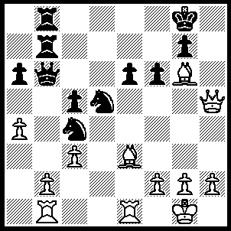
1.Bxc5 Qxc5 (1…..Ne7, 2.Qh7+ Kf8, 3.Qh8++), 2.Rxe6 Qxf2+ (2…..Ne7, 3.Qh7+ Kf8, 4.Rxf6+ gxf6, 5.Qf7++), 3.Kxf2 Rxb2+ Rxb2 Rxb2+, 5.Ke1 Re2+ (5…..Rb1+, 6.Bxb1 g6 [6…..Ne7, 7.Qe8++], 7.Qxg6+ Kh8, 8.Re8++), 6.Qxe2 Ne7, 7.Rxe7 Nd6, 6.Re8+ Nxe8, 9.Qxe8++.

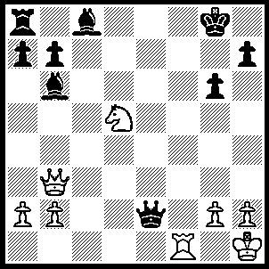
1.Ne7+ Kg7, 2.Qf7+ Kh6, 3.Ng8+ Kh5 (3…..Kg5, 4.Qf4+ Kh5, 5.Nf6++), 4.Qxh7+ Kg4, 5.Nf6+ Kg5, 6.h4++.

