KINGHUNT No.40
by Vern Stannard
Here is another one to let you test your tactical vision.
Set your computer to play human v. human and allow you to take back moves. As you play through the game and its variations see if you can find white’s next move.

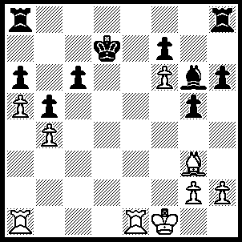
1.Re7+ Kc8 (1…..Kd8, 2.Rd1+ Kc8, 3.Rc7+ Kb8, 4.Rxc6+ Kb7, 5.Rc7+ Kb8, 6.Rc5+ Kb7, 7.Rd7++), 2.Rd1 Ra7 (2…..c5, 3.Rc7+ Kb8, 4.Rxc5+ Kb7, 5.Rd7++ OR 2…..Bf5, 3.Rc7+ Kb8, 4.Rxc6+ Kb7, 5.Rc7+ Kb8, 6.R(d)c1 Bd3+, 7.Kg1 Bc4, R(7)xc4+ Ka7, 9.Rc7+ Kb8, 10.Rc8+ Ka7, 11.R(1)c7++), 3.Rxa7 Bf5 (3…..Re8, 4.Rc7+ Kb8, 5.Re7+ Kc8, 6.Rxe8+ Kb7, 7.Rd7++), 4.Rd6 Re8 (4…..Kb8, 5.R(d)d7+ Kc8, 6.R(d)c7+ Kd8 [6…..Kb8, 7.Rxf7+ Kc8, 8.Ra8++], 7.Ra8+ bc8, 8.R(a)xc8++ OR 4.Bd3+, 5.Rxd3 Re8, 6.Rc7+ Kb8, 7.Re7+ Kc8, 8.Rxe8+ Kb7, 9.Rd7++ OR 4…..h5, 5.Rxc6+ Kd8, 6.Rd6+ Kc8 [6…..Bd7, 7.Ra8+ Kc7, 8.Rb6++], 7.Rb6 Kd8, 8.Rb8+ Bc8, 9.Rc7 h4, 10.R(b)xc8++), 5.Rxc6+ Kd8, 6.Ra8+ Kd7 (6…..Bc8, 7.Rc7 Re1+, 8.Kxe1 g4, 9.R(a)xc8++), 7.Rd6+ Kc7, 8.Rxe8 Kb7 (8…..Bd3+, 9.Rxd3+ Kc6 [9…..Kb7, 10.Rb8+ Kc6, 1.Rb6++], 10.Re7 g4, 11.Rd6++), 9.Rb6+ Ka7, 10.Re7+ Bd7, 11.Rxd7+ Ka8, 12.Rxa6++.

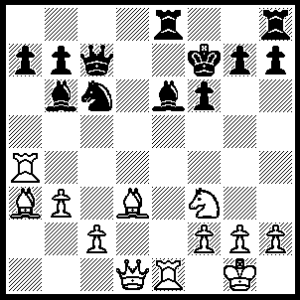
1.Ng5+ Kg8 (1…..fxg5, 2.Qf3+ Kg8 [2…..Qf4, 3.Rxf4+ gxf4, 4.Qxf4+ Kg8, 5.Rxe6 g6 [[5…..Rd8, 6.Re8+ Rxe8, 7.Bc4+ Re6, 8.Bxe6++]], 6.Rxe8+ Kg7, 7.Bf8+ Kg8. 8.Bh6++], 3.Rxe6 Qf7 [3…..Ne7, 4.Rxe7 Rxe7, 5.Bxe7 Qxe7, 6.Bc4+ Qf7, 7.Qxf7++ IF 3…..Rd8, 4.Re8+ Rxe8, 5.Bc4+ Qf7, 6.Qxf7++], 4.Rxe8+ Qxe8, 5.Bc4+ Qf7, 6.Qxf7++), 2.Rxe6 Rxe6, 3.Nxe6 Qc8 (3…..Qf7, 4.Bc4 Ne5, 5.Rxa7 h6 [5…..Bxh7, 6.Qd8+], 6.Ng5 hxg5, 7.Bxg7+ Kxf7, 8.Rxb7+ Kg6, 9.Rxb6), 4.Qg4 Qd7 (4…..g6, 5.Bxg6 Bxf2+, 6.Kxf2 Ne5, 7.Bxh7+ Kf7, 8.Qg7+ Kxe6, 9.Qe7+ Kd5, 9.Qd6++ OR 4…..g5, 5.Qf5 Bd4, 6.Rxd4 Nxd4, 7.Qxf6 Nxe6, 8.Bc4 Qxc4, 9.bxc4 h5, 10.Qxe6), 5.Bc4 g6 (5…..Ne5, 6.Ng5+ Nxc4, 7.Qxc4+ Qf7, 8.Qxf7++), 6.Nf4+ Kg7, 7.Nh5+ Kh6, 8.Qf4+ g5 (8…..Kxh5, 9.Be2+ Qg4, 10.Bxg4+ Kh4, 11.g3++), 9.Qxf6+ Kxh5, 10.Bf7+ Qxf7, 11.g4+ Kh4, 12.Qh6+ Qh5, 13.Qxh5++.

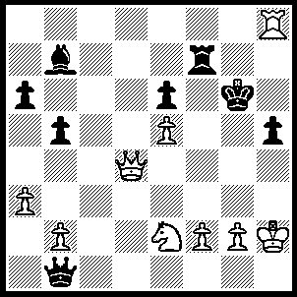
1.Nf4+ Kf5/g5 (1…..Kg7, 2.Qd8 Qh1+, 3.Kxh1 Bxg2+, 4.Kxg2 Rxf4 [4…..Rf8, 5.Qxf8++], 5.Qg8++), 2.Rxh5+ Kg4, 3.f3+ Bxf3, 4.gxf3+ Kxf3, 5.Rh3+ Kg4, 6.Nxe6+ Kf5, 6.Rh5+ Kxe6 (7…..Kg6, 8.Qg4++), 8.Qd6++.

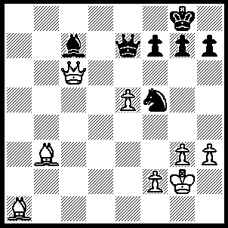
1.e6 Nd6 (1…..fxe6, 2.Bxe6+ OR 1…..Nh6, 2.exf7+ Nxf7 [2…..Kf8,3.Qe8+ Qxe8, 4.Bxg7+ Ke7, 5.fxe8(Q)+ Kxe8, 6.Bxh6], 3.Qc3 Be5, 4.Qxe5 Qxe5, 5.Bxe5 OR 1…..f6, 2.Qa8+ Qf8, 3.e7+ OR 1.Kf8, 2.exf7 Nd6 returns to game ), 2.exf7 Kf8 (2…..Ncf7, 3.Qc3 Be5, 4.Qxe5 Qxe5, 5.Bxe5 OR 2…..Kh8, 3.Qc3 Nf5, 4.Qxf7 Qf8, 4.Qd7 Nd6, 6.Be5 h5, 7.Bxd6), 3.Bxg7+ Kxg7, 4.Qc3+ Kg6 (4…..Kh6, 5.Qe3+ Qxe3, 6.f8(Q)+ kg6, 7.fxe3), 5.Qh8 Qe4+ (5…..Nxf7, 6.Bc2+ Kg5, 7.Qg7+ Kh5, 8.Qxh7+ Nh6, 9.Qg6++), 6.Kh2 Nxf7 (6…..Nf5, 7.Qg8+ Kh5, 8.Bd1+ Kh6, 9.f8(Q)+ Ng7, 10Q(f)xg7++), 7.Qg8+ Kh6, 8.Qf8+ Kg5 (8…..Kg6, 9.Qxf7+ Kh6, 10.Qxc7), 9.Qg7+ Qg6 (9…..Kf5/h5, 10.Qxf7+), 10.f4+ Kh5 (10…..Kf5, 11.Bc2+ Ke6, 12.f5+), 11.Bd1 Qg4, 12.Bxg4++.
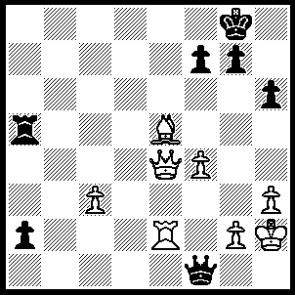
1.Rd2 f6 (1…..Kf8, 2.Rd8+ Ke7, 3.Bf6+ Kxdf6, 4.Rd6++ OR 1…..g6, 2.Rd8+ Kh7, 3.Rh8++), 2.Rd8+ Kf7, 3.Bxf6 a1(Q) (3…..Kxf6, 4.Rf8++ OR 3…..gxf6, 4.Qe8+ Kg7, 5.Qg8++), 4.Rd7+ Kxf6, 5.Qc6+ Kf5, 6.Rf7++.

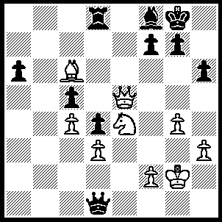
1.Qc7 Be7 (1…..Qxd3, 2.Qxd8 Qxc4, 3.Bd5 Qc1, 4.Nf6+ gxf6, 5.Qxf6 Qg5 [5…..Bg7, 6.Qxf7+ Kh7, 7.Be4+ Kh8, 8.Qe8+ Bf8, 9.Qxf8++], 6.Qxf7+ Kh8, 7.Qxf8+ Kh7, 8.Be4+ Qg6, 9.Qf7+ Kh8, 10.Bxg6 d3, 11.Qh7++), 2.Qxe7 Rf8, 3.Nxc5 Qb1, 4.Nd7 Rc8, 5.Bd5 Kh8 (5…..a5, 6.Qxf7+ Kh7 [6…..Kh8, 7.Nf8 Rxf8, 8.Qxf8+ Kh7, 9.Bg8+ Kg6, 10.Qf5++], 7.Nf8+ Rxf8, 8.Be4+ Kh8, 9.Qxf8++), 6.Qxf7 Qb4 (6…..Qxd3, 7.Nf8 Rxf8, 8.Qxf8+ Kh7, 9.Bg8+ Kg6 [9…..Kh8, 10.Bf7+ Kh7, 11.Qg8++], 10.Qf7+ Kg5, 11.f4+ Kh4, 12.Qh5++), 7.Ne5 Rd8 (7…..Qd6, 8.Qf5), 8.Ng6+ Kh7, 9.Ne7 Qd6 (9…..Kh8, 10.g5 Qd6, 11.c5 Qd7 [11…..Qxc5, 12.gxh6 Qxe7, 13.g8(Q)+ Kh6, 14.Q(f)g6++], 12.Ng6+ Kh7, 12.Nf8+ Rxf8, 14.g6+ Kh8, 15.Qxf6++), 10.Qf5+ Kh8 (10…..g6, 11.Qf7+ Kh8, 12.Nxg6+ Qxg6, 13.Qxg6), 11.Ng6+ Qxg6 (11…..Kh7, 12.Nf8+ Kh8, 13.Qh7++), 12.Qxg6 Rxd5, 13.Qe8+ Kh7, 14.Qe4+ Rf5, 15.Qxf5+.

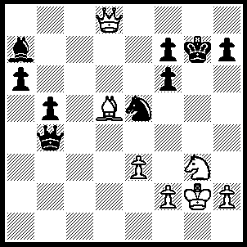
1.Nf5+ Kg6, 2.Qg8+ Kh5 (2…..Kxf5, 3.Qxh7+ Kg4 [3…..Ng6, 4.Qh5++], 4.h3+ Kg5, 5.f4+ Qxf4, 6.exf4++), 3.Qxh7+ Kg5 (3…..Kg4, 4.Qh4+ Kxf5. 5.Qh5++), 4.Qh6+ Kg4, 5.Qh4+ Kxf5, 6.Qh5++.

