KINGHUNT No.41
By Vern Stannard
You should set your computer for human to play human and then set it to allow you to take back moves. By doing this you will then be able to play through the game and the variations and sub-variations, simply and easily, by back tracking to where you diverted into a variation or sub-variation and continuing your exploration.
Try and anticipate white’s next move as you go to improve your tactical visualisation.
As usual in some variations Black avoids mate with a massive loss of material.

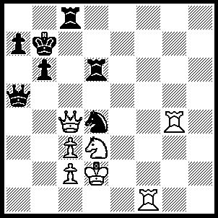
1.Rg7+ Kb8, 2.Rf8 Nb3+ (2…..Nf3+, 3.Ke2 Nd4+ [3…..Ng1+ Ke3 Rxf8, 6.Qd6+], 4.cxd4 Qh5+, 5.Kd2 Qh6+, 6.Kd1 Qh1+ [6…..Qh5+, 7.Kc1], 7.Ne1 Qc6 [7…..Rxd4+, 8.Qxd4 Qh5+ [[8…..Rxf8, 9.Qd6+], 9.Nf3], 8.Rxc8+ Kxc8 [8…..Qxc8, 9.Rg8], 9.Qa6+ Kd8, 10.Rg8+ Ke7 [10…..Kd7, 11.Qxa7+ Ke6, 12.Qg7+ Ke6, 12.Qg7 Qd7, 13.Qe5+ Kf7, 14.Rg7+], 11.Qxa7+ Rd7, 12.Rg7+ Ke6, 13.Rxd7 Qxd7, 14.Qxb6+), 3.cxb3 Qc5, 4.Rxc8+ Kxc8 (4…..Qxc8, 5.Qf7 Rd7, 6.Qxd7 Qxd7, 7.Rxd7), 5.Qa6+ Kd8, 6.Rg8+ Ke7 (6…..Kd7, 7.Qb7+ Qc7 [7…..Ke6, 8.Rg6+ Kf5, 9.Qf7+ Rf6 [[9…..Ke4, 10.Rg4++]], 10.Qxf6+ Ke4, 11.Qf4+ Kd5, 12.Qe5++], 8.Rg7+ Ke8, 9.Qxc7 Rxd3+, 10.Kxd3 b5, 11.Qe7++), 7.Qxa7+ Ke6 (7…..Kf6, 8.Qg7+ Kf5 [8…..Ke6, 9.Re8+ Kf5 [[9…..Ke4, 10.Qg2++]], 10.Rf8+ Rf6 [[ 10…..Ke4, 11.Qg2++]], 11.Rxf6+ Ke4, 12.Qg2++], 9.Rf8+ Ke4, 10.Qg2++ OR 7…..Rd7, 8.Rg7+ Kf6, 9.Qxd7 Qf8, 10.Qd4+ Ke6/g5, 11.Qe5++), 8.Rg6+ Kd5 (8…..Kf5, 9.Qf7+ Rf6 [9…..Ke4, 10.Rg4++], 10.Qxf6+ Ke4, 11.Rg4+ Kd5, 12.Rg5+ Ke4, 13.Qf4++), 9.Qb7+ Qc6, 10.c4+ Ke4 (10…..Kd4, 11.Rg4+ Qe4, 12.Rxe4++), 11.Qe7+ Re6 (11…..Kf5, 12.Rg5++), 12.Qh4+ Kf5 (12…..Kf3, 13.Qf4++), 13.Qg4++.

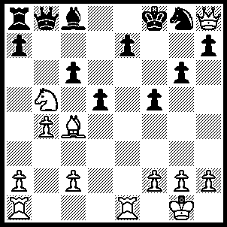
1.Rxe7 Qe5 (1…..Kxe7, 2.Qg7+ Kd8 [2…..Ke8, 3.Re1+ Be6 [[3…..Kd8, 4.Qxg8+ Kd7, 5.Qe8++]], 4.Rxe6+ Kd8, 5.Qf8+ Kd7, 6.Qf7+ Ne7, 7.Rxe7+ Kc8, 8.Qe8++], 3.Qf8+ Kd7, 4.Qf7+ Kd8, 5.Re1 Be6, 6.Rxe6 Nf6, 7.Qf8+ Kd7, 8.Re7++), 2.Rxe5 Bd7 (2…..dxc4, 3.Re7 Kxe7, 4.Qg7+ Kd8 [4…..Ke8, 5.Nc7+ Kd8, 6.Rd1+ Bd7, 8.Qxd7++], 5.Rd1+ Ke8, 6.Nc7++ OR 2…..cxb5, 3.R(a)e1 Be6, 4.Rxe6 Kf7 [4…..dxc4, 5.Rf6++], 5.Bxd5 f4, 6.Re8++), 3.Re7 Kxe7, 4.Qg7+ Kd8, 5.Qf8+ Be8 (5…..Re1+ Be6, 6.Rxe6+ Kd8, 7.Qc7++), 6.Re1 cxb5 (6…..Nf6, 7.Qe7+ Kc8, 8.Qc7++ OR 6…..dxc4, 7.Qxe8++ OR 6…..Kc8, 7.Qxe8+ Kb7, 8.Qd7+ Kb6, 9.Qc7+ Ka6, 10.Qxc6++), 7.Rxe8+ Kc7 (7…..Kd7, 8.Bxb5+ Kc7, 9.Qc5+ Kb7, 10.Qc6++), 8.Qc5+ Kb7 (8…..Kd7, 9.Nxb5++), 9.Bxd5+ Ka6. 10.Re6++.

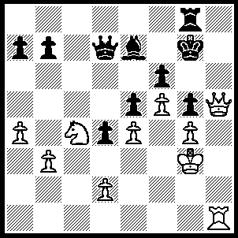
1.Qh7+ Kf8, 2.Nxe5 fxe5, 3.f6 Qe6, 4.fxe7+ Qxe7 (4…..Ke8, 5.Rc1 Qxb3+ [5…..Kd7, 6.e8(Q)+ Kxe8, 7.Qxb7 Qd7 [[7…..Kd8, 8.Rc7 Qxb3+, 9.Qxb3 Kxg7, 10.Qxg8]], 8.Rc8+ Qxc8, 9.Qxc8+], 6.Kg2 Qe6, 7.Rc8+ Qxc8 [7…..Kd7, 8.e8(Q)+ Kd6, 9.Qc7++], 8.Qxg8+ Kd7, 9.Qxc8+ Kxc8, 10.e9(Q)+), 5.Rf1+ Ke8, 6.Qxg8+ Kd7, 7.Qd5+ Ke8 (7…..Qd6, 8.Qxb7+ Kd8 [8…..Ke6, 9.Qf7++], 9.Rf7 Ke8, 10.Rh7 Qc7, 11.Qxc7 d3, 12.Qe7++ OR 7…..Kc7, 8.Rc1+ Kb8 [8…..Ke6, 9.Qf7++], 9.Qg8+ Qd8, 10.Qxd8++), 8.Rc1 Kf8, 9.Rc8+ Kg7, 10.Qg8+ Kh6, 11.Rc1 Qg7, 12.Qe8 Qe7 (12…..Qf6, 13.Rh1+ Kg7, 14.Qh8+ Kf7, 15.Rh7+ Qg7 [15…..Ke6, 16.Qg8+ Qf7 [[16…..Kd6, 17.Qd5++]], 17.Qxf7+ Kd6, 18.Qd5++], 16.Qxg7+ Ke6, 17.Qe7++), 13.Rh1+ Kg7, 14.Qxe7+ Kg8, 15.Rf1 d3, 16.Rf8++.
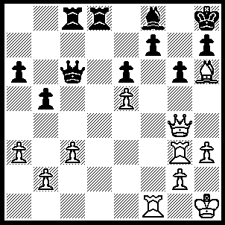
1.Rxf7 Rd7 (1…..Rc7, 2.Rxh7+ Rxh7 [2…..Kg8, 3.Qxg6+ Bg7, 4.Rxg7+ Kf8, 5.Rxc7++ OR 2…..Bxh6, 3.Qf6+ Rg7 [3…..Bg7, 4.Qxd8+ Qe8, 5.Qxe8+ Bf8, 6.Qxf8++], 4.Qxh6+ Rh7, 5.Qf6+ Rg7, 6.Qxg7++), 3.Qxg6 Qxg2+ (3…..Be7, 4.Bg7+ Kg8, 5.Bf6+ Kf8, 6.Qg8++), 4.Rxg2 Rd1+, 5.Kh2 Rh1+, 6.Kxh1 Rg7, 7.Bxg7+ Kg8, 8.Bf6+ Bg7, 9.Qxg7++), 2..Rxf8+ Rxf8, 3.Bxf8 Rf7, 4.Bh6 Rf5 (4…..Qd7, 5.Qe2 Qe7, 6.Qd2 Rf8 [6…..a5, 7.Rd3 Rf1+, 8.Kh2 Rf8, 9.Bxf8 Qc7, 10.Bh6 Kg8, 11.Rd8+ Kf7, 12.Qf4+ Ke7, 13.Qf8++], 7.Rd3 Qc5 [7…..Rc8, 8.Rd7 Qh4, 9.Bg7+ Kg8, 10.Bf6 IF 7.Kg8, 8.Bxf8 Qxf8, 9.Rd8 h5, 10.Rxf8+ IF 7…..Re8, 8.Rd7 Qh4 [[8…..Qc5, 9.Qf4 Rg8, 10.Qf6+ Rg7, 11.Qxg7++]], 9.Bg7+ Kg8, 10.Bf6], 8.Rd8 Qxe5+, 9.g3 Qe2+, 10.Qxe2 Rxd8, 11.Qe5+ Kg8, 12.Qg7++), 5.Rd3 Qe8, 6.Qh4 g5 (6…..Rh5, 7.Qf6+ Kg8, 8.Qg7++), 7.Bxg5 Qg6 (7…..Rxg5, 8.Qxg5 h6, 9.Qxh6+ Kg8, 10.Rg3+ Kf7, 11.Qf6++), 8.Rd8+ Kg7, 9.Bf6+ Rxf6 (9…..Kf7, 10.Qb4 Rf1+ [10…..Qh6, 11.Qe7+ Kg6, 12.Qe8++], 11.Kh2, Qh6, 12.Rd7+ Kg8 [12…..Kg6, 13.Qg4+ Qg5, 14.Qxg5++], 13.Qg4+ Qg6, 14.Qxe6+ Qf7, 15.Qxf7++) 10.exf6+ Kf7 (10…..Qxf6, 11.Rg8+ Kxg8, 12.Qxf6), 11.Rd7+ Ke8, 12.Re7+ Kf8, 13.Qd4 Qe8, 14.Rg7 Qd7, 15.Qxd7 b4, 16.Qf7++.

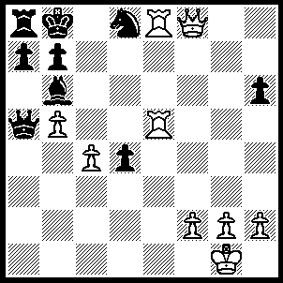
1.Qd6 Kc8, 2.g3 d3 (2…..a6, 3.R(5)e7 Ra7, 4.Qd7+Kb8, 5.c5 Bc7, 6.b6 Bxb6, 7.cxb6 Qa1+, 8.Kg2 d3, 9,Rxd8++), 3.Kg2 a6 (3…..d2, 4.R(5)e7 Bc7, 5.Qd7+ Kb8, 6.Rxd8+ Bxd8, 7.Qxb7++ OR 3…..a6, 4.R(5)e7 Bc7 [4…..Ra7, 5.Qd7+ as before], 5.Rxd8+ Bxd8, 7.Qxb7++), 4.R(5)e7 Ra7, 5.Qd7+ Kb8, 6.c5 Bc7 (6…..Qb5, 7.Qxd8+ Bxd8, 8.Rxd8++), 7.b6 Bxb6, 8.cxb6 Qd5+, 9.Qxd5 d2, 10.Rxd8++.

