KINGHUNT No.43
by Vern Stannard
Here is another batch to let you test your tactical vision.
Set your computer to play human v. human and allow you to take back moves. As you play through the games and their variations see if you can anticipate White’s next move and so improve your storehouse of tactical expertise. Some variations do not end in mate but stop after a massive material advantage is reached.

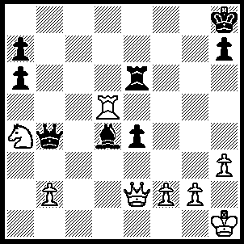
1.Rd8+ Kg7, 2.Qg4+ Rg6 (2…..Kf6, 3.Qf4+ Kg7 [3…..Kg6, 4.Rg8+ Bg7, 5.Qxg4+ Kf6, 6.Qxg7+ Kf5, 7.Qg5++], 4.Rd7+ Re7 [4…..Kg6, 5.Qf7+ Kg5, 6.h4+ Kxh4 [[6…..Kg4, 7.Qxe6+ Kxh4, 8.g3+ Kg5, 9.Rd5+ Be5, 10.Rxe5++], 7.Qf4+ Kh5, 8.Qf5+ Kh4, 9.g3++], 5.Qg5+ Kf8 [5…..Kf7, 6.Qd5+ Kg6, 7.Rxe7 Qxe7, 8.Qxd4], 6.Rd8+ Re8 [6…..Kf7, 7.Qd5+ Re6, 8.Qxd4], 7.Qf5+ Kg7 [7…..Ke7, 8.Rd7++], 8.Rxe8 Qd6 [8…..Qxa4, 9.Re7+ Kh6, 10.Rxh7++ IF 8…..Bf6, 9.Nc5 Qe1+, 10.Kh2 Qa5, 11.Ne6+ Kf7, 12.Rf8+ Ke7, 13.Qxf6+], 9.Qg4+ Kf7, 10.Qg8+ Kf6, 11.Qxh7 e6, 12.Qh6+ Kf7, 13.Qxd6),
3.Qxe4 Qxa4, 4.Rxd4 Qb3 (4…..Qa1+, 5.Kh2 Qxb2, 6.Qe7+ Kh8 [6…..Kh6, 7.Rh4++], 7.Qf8+ Kg8, 8.Qf6+ Rg7, 9.Rd8++),
5..Qe5+ Rf6 (5…..Kf7, 6.Rd7+ Kf8, 7.Qe7+ Kg8, 8.Rd8++ OR 5…..Kg8, 6.Rd8+ Kf7, 7.Rd7+ mates),
6.Rg4+ Kf7, 7.Qc7+ Ke6 (7…..Ke8, 8.Rd4 Qb8, 9.Qxb8 OR 7…..Kf8, 8.Qd8+ Kf7, 9.Qg8+ Ke7, 10.Qxb3),
8.Re4+ Kf5 (8…..Kd5, 9.Re5+ Kd4, 10.Qc5+ Kd3, 11.Qe3+ Kc2 [11…..Kc4, 12.Qe4++], 12.Rc5+ Kb1, 13.Qc1+ Ka2,14.Ra5+ Qa3, 15.Rxa3++),
9.Qf4+ Kg6, 10.Qg4+ Kh6 (10…..Kf7, 11.Qd7+ Kg8 [11…..Kg6, 12.Rg4+ Kh6, 13.Qg7+ Kh5, 14.Qg5++], 12.Re8+ Rf8, 13.Qg4+ Kf7, 14.Qh5+ Kf6 [14…..Kg8, 15.Qg5+ Kf7, 16.Re7++], 15.Qh6+ Kf7 [15…..Kf5, 16.g4++], 16.Rxf8+ Ke7, 17.Qf6+ Kd7, 18.Rd8+ Kc7, 19.Qd6+ Kb7, 20.Rb8++),
11.Re5 Qd1+, 12.Qxd1.

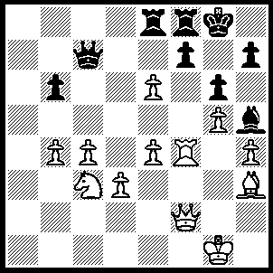
1.Nd5 Qb7 (1…..Qd8, 2.exf7+ Rxf7 [2…..Kg7, 3.Qd4+ Re5, 4.Qxe5+ Qf6, 5.Qxf6++],, 3.Rxf7 Bf3 [3…..Rf8, 4.Rxf8+ Qxf8, 5.Be6+ Kg7, 6.Qd4+ Qf6, 7.Qxf6++], 4.Rd7 Qc8 [4…..Qxd7, 5.Nxf6], 5.Nf6+ Kf8 [Kh8, 6.Rxh7++], 6.Qxf3 Qxd7 [6…..Re7, 7.Nd5+ Kg8 [[7…..Ke8, 8.Nxe7+ Kd8, 9.Qf8++]], 8.Nxe7+ Kh8/g7, 9.Qf6++], 7.Nxd7+ Kg7, 8.Qf6+ Kg8, 9.Be6+ Rxe6, 10.Qf8++ OR 1…..Qa7, 2.Nf6+ Kh8, 3.Qd4 Ra8, 4.Nxh5+ f6, 5.e7 Qa1+, 6.Qxa1 Rxa1+, Kf2 R(a)a8, 8.exf8(Q)+ Rxf8, 9.Rxf6 Rb8, 10.f4.),
2.Nf6+ Kh8, 3.Qd4 Rd8, 4.Nd7+ Kg8 (4…..f6, 5.Rxf6 Kg8 [5…..Rxf6, 6.Qxf6+ Kg8, 7.Qxd8+ Kg7, 8.Qf8++], 6.Rf7 Rxf7, 7.exf7 Kxf7, 8.Qf6+ Kg8, 9.Be6++),
5.exf7+ Rxf7, 6.Rxf7 Kxf7, 7.Qf6+ Kg8, 8.Be6++.
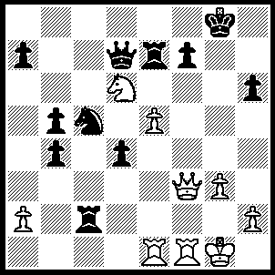
1.Qa8+ Kg7 (1…..Kh7, 2.Ne4 2.Re6, 3.Qf8 Nxe4, 4.Rxf7+ Qxf7, 5.Qxf7+ Kh8, 6.Qxe6 Nc5, 7.Qxh6+ Kg8, 8.Rf1 Nd7, 9.Qg6+ Kh8, 10.Rf4 mates OR 2…..Qe6, 3.Nf6+ Kg6, 4.Qg8++ OR 2…..Nxe4, 3.Qxe4+ Kg8, 4.Qxc2), 2.Nf5+ Kh7, 3.Qf8 Ne6 (3…..Qxf5, 4.Rxf5 Rb7, 5.Rf6 Rb6, 6.Rxf7+ Kg6, 7.Qg8+ Kh5, 8.Rf5++), 4.Qxh6+ Kg8, 5.Re4 f6, 6.exf6 Rh7 (6…..Rf7, 7.Rh4 Rh7 [7…..Rf8, 8.Ne7+ Qxe7 [[8…..Kf7, 9.Qh5++]] 9.f7+ R/Qxf7, 10.Qh8++], 8.Ne7+ Qxe7, 9.fxe7 Rxh6, 10.e8(Q)+ Kh7, 11.Rf7+ Ng7, 12.Rxh6+ Kxh6, 13.Qh8+ Kg6 [13…..Kg5, 14.Qh4+ Kg6, 15.Rf6++], 14.Qxg7+ Kh5, 15.Rf5++), 7.Ne7+ Rxe7 (7…..Kf7, 8.Qg6+ Kf8, 9.Qg8++), 8.fxe7 Qxe7, 9.Rh4 Qxh4 (9…..Nf4, 10.Rg4+ Kf7, 11.Qg6+ Kf8, 12.Qg8++), 10.Qxe6+ Kh8 (10…..Kg7/h7, 11.Rf7+ Kg8, 12.Qe8++), 11.Rf8+ Kg7/h7, 12.Rf7+ Kg8, 13.Qe8++.

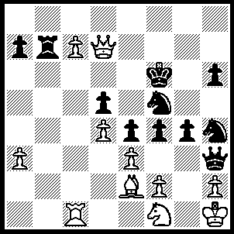
1.Rc6+ Kg5 (…..Nd6, 2.Qxd6+ Kg5 [2…..Kg7, 3.Qg7+ Kh8, 4.c8(Q)++], 3.Qxh6+ Kf5, 4.Qf5++),, 2.Qd8+ Kh5 (2…..Ne7, 3.Qxe7+ Kh5, 4.Qe8+ Kg5, 5.exf4+ Kf4 [5…..Kf5, 6.Qf7++], 6.Qe5++), 3.Qe8+ Kg5, 4.Qg8+ Kh5, 5.Qf7+ Kg5, 6.Qf6+ Kh5, 7.Qxf5+ Nxf5, 8.c8(Q) Ne7 (8.Rf7, 9.Qe6 Kh4, 10.Qxf7 f3, 11.Qf6+ Kh5, 12.Qxf5+ Kh4, 13.Rh6++), 9.Qe6 Qxf1+ (9…..Nxc6, 10.Ng3+ fxg3 [10…..Qcg3, 11.Qf5+ Kh4, 12.hxg3+ Kh3, 13.Qxg4++ IF 10…..Kg5, 11.Qf5+ Kh4, 12.Qh5++], 11.Qf5+ Kh4, 12.fxg3+ Qxg3, 13.hxg3+ Kxg3, 14.Qf4+ Kh4, 15.Qxg4++), 10.Bxf1 Nxc6 (10…..g3, 11.Qxh6+ Kg4, 12.Qxf4+ Kh5, 13.Be2++), 11.Qf5+ Kh4, 12.Qg6 Rh7 (12…..h5, 13.Qf6++ OR 12…..g3, 13.hxg3+ fxg3, 14.fxg3++), 13.Qxh7 Kg5 (13…..g3, 14.Qxh6+ Kg4, 15.f3+ Kxf3 [15…..exf3,16.Bh6++], 16.Qxf4++), 14.Qg7+ Kh5 (14…..Kf5, 15.Qf7+ Kg5, 16.exf4+ Kh4, 17.Qg6 g3, 18.hxg3++), 15.Qf7+ Kh4, 16.Qg6 g3, 17.hxg3+ fxg3, 18.fxg3++.

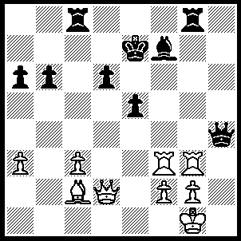
1.Rxf7+ Kxf7 (1…..Ke6, 2.Bf5+ Kxf7, 3.Qd5+ Ke7, 4.Qe6+ Kd8,5.Qxd7++ OR 1…..Ke8, 2.Rxg8+ Kxf7, 3.Qd5+ Ke7, 4.Rg7+ Kd8, 5.Qg8++), 2.Qd5+ Ke7 (2…..Kf6, 3.Qxd6+ Kf7, 4.Bb3+ Rc4, 5.Qd5+ Kf6 [5…..Ke7, 6.Rxg8 b5, 7.Rg7+ Kf6 [[7…..Ke/d8, 8.Qg8++]], 8.Qf7++], 6.Rxg8 b5, 7.Qd6+ Kf7 [7…..Kf5, 8.Qg6+ Kf4, 9.Rf8+ Qf6, 10.Rxf6++], 8.Qg6+ Ke7, 9..Rg7+ Kd8, 10.Qd6+ Kc8, 11.Qd7+ Kb8, 12.Qb7++), 3.Qb7+ Kf6 (3…..Ke6, 4.Bb3+ Rc4 [4…..d5, 5.Qxd5+ Ke7, 6.Qe6+ Kd8, 7Qd6+ Ke8, 8.Rxg8++], 5.Rxg8 b5, 6.Rg6+ Kf5, 7.Qf7+ Ke4, 8.Qf3++), 4.Rf3+ Kg5 , 5.Qe7+ Kh5 (5…..Kg5, 6.Qe6+ Kh5 [6…..Kg5, 7.Rf5+ Kg4, 8.Bd1++], 7.Qf5+ Kh6 [7…..Qg4, 8.Rh3++ IF 7…..Rg4, 8.Qh7++], 8.Qh7+ Kg5 9.Rf5+ Kg4, 10.Bd1++), 6.Qh7+ Kg5 (6…..Kg4, 7.Qf5++), 7.Rf5+ Kg4, 8.Bd1++.

