KINGHUNT No.44
by Vern Stannard
Here is another lot to let you test your tactical vision.
Set your computer to play human v. human and allow you to take back moves. As you play through the game and its variations see if you can find white’s next move and the tactical theme behind it.

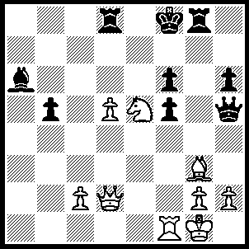
1Qb4+ Ke8, 2.Re1 Rg7 (2…..fxe5, 3.Rxe5+ Kd7 [3…..Kf7, 4.Qe7+ Kg6, 5.Re6++], 4.Re7+ Kc8, 5.Qc5++), 3.Nd7+ Kf7 (3…..Kxd7, 4.Qd6+ Kc8, 5.Qb8+ Kd7, 6.Qc7++), 4.Qe7+ Kg6 (4…..Kg8, 5.Nxf6+ Kh8, 6.Qxd8+ Rg8, 7.Qxg8++), 5.Qxd8 f4 (5…..Kh7, 6.Nxf6+ OR +5…..Rxd7, 6.Qxd7 Qg4 [6…..f4, 7.Qe8+ Kg5 [[7…..Kf5, 8.Qxh5++ IF 7…..Kg7, 8.Re7+ mates]] 8.Bxf4+ Kg4 [[8…..Kxf4, 9.Qxh5 Be8, 10.g3++]], 9.Qe6+ Kxf4 [[9…..Qf5, 10.h3+ Kxf4 {{10…..Kh4, 11.g3+ Kxh3, 12.Qxf5++}}, 11.Qe3++]] 10.Rf1+ Qf3, 11.Rxf3+ Kg5, 12.Qf5+ Kh4, 13.g3++], 7.Qe8+ Kh7 [7…..Kg5, 8.h4+ Qxh4, 9.Qg8+ Kh5, 10.Bxh4 Bc8 [[10…..Kxh4, 11.Kf2 b4, 12.Rh1++]], 11.Bxf6 Be6, 12.g4+ fxg4, 13.Re5+ Bf5, 14.Rxf5++], 8.Re7+ Qg7, 9,d6 b4, 10.Qf6 Qxe7, 11.dxe7 Bc4, 12.Qf7+ Kh8, 13.Bh4 a5, 14.Bxf6++), 6.Nf8+ Kf5 (6…..Kg5, 7.Re5+ Kg4, 8.Qxf6 Rf7, 9.Nd7 Bc8 [9…..Qxe5, 10.Nxe5+ Kh5, 11.Qg6++], 10.Rxh5 Kxh5 [10…..Bxd7, 11.Qh4++], 11.Qxf7+ Kg5, 12.Qf6+ Kg4, 13.Qg6++), 7.Qd6 Qg4 (7…..Rg4, 8.Qe6+ Kg5, 9.Re5+ fxe5, 10.Qxe5++ OR 7…..fxg3, 8.Qe6+ Kg5 [8…..Kf4, 9.Qe4+ Kg5, 10.Ne6++], 9.Qe3+ Kh4 [9…..Kf5/g4, 10.Qe4+ Kg5, 11.Ne6++], 10.Qf4+ Qg4 [10…..Rg4, 11.hxg3++], 11.Qxh6+ Qh5, 12.Re4+ Rg4, 13.Ng6++), 8.Qe6+ Kg5, 9.Re5+ fxe5, 10.Qxe5+ Qf5, 11.Ne6+ Kg6 (11…..Kg4, 12.h3+ Kh5 [12…..Kxg3, 13.Qe1++], 13.Qf5+ Rg5, 14.Nxf4++), 12.Qxg7+ Kh5, 13.Nxf4+ Qxf4, 14.Bxf4 b4, 15.Qxh6+ Kg4, 16.Qg5++.

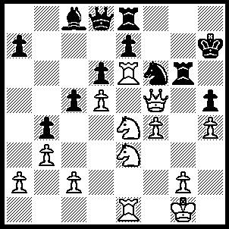
1`.Nxf6+ exf6 (1…..Kh6, 2.N(f)g4+ Kh7 [2…..Kg7, 3.Rxg6+ Kh7/8, 4.Qxh5++], 3.Qxg6+ Kh8, 4.Nf5 hxg4, 5.Qg7++ OR 1…..Kg7, 2.Nxh5+ Kh8, 3.Qxg6 Bxe6, 4.Qg7++ OR 1…..Kh8, 2.Qxh5+ Kg7, 3.Qh7+ Kf8, 4.Nd7+ Qxd7, 5.Rxg6 Qe6, 6.Qg7++), 2.Qxh5+ Kg8 (2…..Rh6, 3.Qf7+ Kh8, 4.Rxe8+ Qxe8, 5.Qxe8 Kh7 [5…..Kg7, 6.Nf5+ Bxf5 [[6…..Kh7, 7.Re7++]], 7.Re7++], 6.Qf7+ Kh8, 7.Nf5 Rg6, 8.Re8+ Rg8, 9.Qxg8++), 3.Qxg6+ Kf8 (3…..Kh8, 4.Nf5 Qe7 [4…..Re7, 5.Qxf6+ Kg8 [[5…..Kh7, 6.Rxe7+ Qxe7, 7.Rxe7+ Kg8, 8.Nh6++]] 6.Nh6+ Kh7, 7.Rxe7+ Qxe7, 8.Rxe7++], 5.Rxe7 Rxe7, 6.Rxe7 Bxf5, 7.Qg7++), 4.Nf5 Rxe6 (4…..Re7, 5.Rf6+ Rf7, 6.Qxf7++), 5.Qg7+ Ke8, 6.dxe6 Bxe6, 7.Rxe6+ Qe7, 8.Qxe7++.

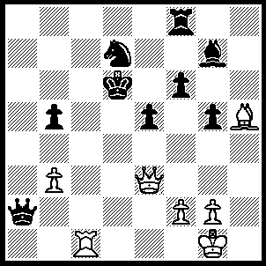
1.Qd3+ Ke7 (1…..Ke6, 2.Rd1 Qa7, 3.Qd6+ Kf5, 4.g4+ Kf4 [4…..Ke4, 5.Qd3+ Kf4, 6.Qf5++], 5.Qd2+ Ke4, 6.Qd3+ Kf4, 7.Qf5++), 2…Rd1 Qa7 (2…..Rd1/Nc5, 3.Qd6++), 3.Qh7 Kd8 (3…..Rf7, 4.Qg8 Rf8 [4…..Ke6, 5.Bxf7+ Kf5, 6.Qh7+ Kf4, 7.g3+ Kg4 [[7…..Kf3, 8.Qf5+ Ke2, 9.Qd3++]], 8.Qh5+ Kf5, 9.Qf3++], 5.Qxg7+ Ke6, 6.g4 Qb7 [6…..Qc7,, 7.Bg6 e4, 8.Bf5+ Ke5, 9.Qe7+ Kf4, 10.Qxe4++], 7..Bg6 e4, 8.Bf5+ Ke5, 9.Qe7+Kf4, 10.Qd6+ Kf3, 11.Rd3+ Ke2, 12.Re3++), 4.Qxg7 Kc8 (4…..Re8, 5.Qf7 Rh8 [5…..Re7, 6.Qf8+ Kc7, 7.Qxe7 Kc8, 8.Qe8+ Kc7, 9.Qxd7+ Kb8, 10.Qd8+ Kb7, 11.Bf3+ Ka6, 12.Ra1++], 6.Bg4 f5, 7.Bxf5 Kc8, 8.Rxd7 Qc5, 9.Rd8+ Kxd8, 10.Qd7++), 5.Bg4 Rd8 (5…..f5, 6.Rxd7 Qxd7, 7.Qxf8+ Kb7, 8.Qxf5 Qxf5, 9.Bxf5), 6..Bxd7+ Rxd7 (6…..Kb8, 7.Qxf6 Qc7 [7…..Rxd7, 8.Qf8+ Kc7, 9.Rc1+ Kb7 [[9…..Kb6, 10.Qc5+ Ka6 {{10…..Kb7, 11.Qc6+ Kb8, 12.Qc8++}}, 11.Ra1+ Kb7, 12.Rxa7+ Kb8, 13.Qb6+ Kc8, 14 Ra8++], 10.Qc8+ Kb6, 11.Qc6+ Ka5, 12.b4+ Ka4, 13.Qc2+ Kxb4, 14.Qc3+ Ka4, 15.Ra1++], 8.Qe6 e4, 9.Qd5 Qb7 [9…..b4, 10.Ra1 Qb7, 11.Qd6+ Qc7, 12.Ra8+ Kxa8, 13.Qxc7 Rxd7, 14.Qxd7], 10.Qe5+ Qc7, 11.Qxb5+ Qb7, 12.Qxb7+ Kxb7, 13.Bc6+ Kc7, 14.Rxd8 Kxd8, 15.Bxe4), 7.Qf8+ Kc7, 8.Rc1+ Kb6, 9.Qc5+ Ka6, 10.Ra1+ Kb7, 11.Rxa7+ Kb8, 12.Qb6+ Kc8, 13.Ra8++.

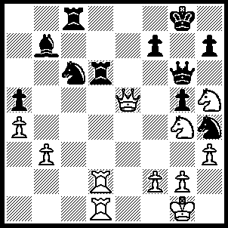
1.Rxd6 f6 (1…..Nxe5, 2.Rd8+ Rxd8, 3.Rxd8++), 2.N(g)xf6+ Kh8, (2…..Kf7, 3.Qe6+ Kf8, 4.Nd7++ OR 2…..Kf8, 4.Nd7+ Kg8,5.Rxg6+ Kf7, 6.Qe6++), 3.Rxc6 Bxc6 (3…..Qf5, 4.Rxc8+ Qxc8, 5.Nxh7+ Kxh7, 6.Qg7++ OR 3…..Nf5, 4.Rxc8+ Bxc8, 5.Rd8+ Qe8, 6.Rxe8++), 4.Nd5+ Kg8, 5.Ne7+ Kf7 (5…..Kf8, 6.Nxg6+ hxg6/Nxg6, 7.Qg7+ Ke8, 8.Nf6++), 6.Nxg6 hxg6/Nxg6 (6…..Kxg6, 7.Qf6+ Kh5, 8.g4++), 7.Qg7+ Ke6, 8.Qf6++.

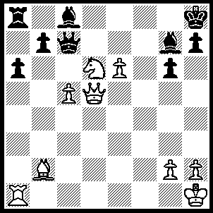
1.Nf7+ Kg8 (1…..Qxf7, 2.exf7 Bf5, 3.Qe5 Rg8, 4.Qxg7+ Rxg7, 5.f8(Q)++), 2.Nh6+ Kh8 2…..Kf8, 3.e7+ Kxe7, 4.Re1+ Be6 [4…..Kf8, 5.Qg8++], 5.Qxe6+ Kd8, 6.Qe8++), 3.e7 Be6 (3…..Qxe7, 4.Qg8++), 4.Rxa6 Bxb2 (4…..Bxd5, 5.Rxa8+ Bg8, 6.Rxg8++ OR 4…..Rxa6, 5.Qd8+ Qxd8, 6.exd8(Q)+ Bf8, 7.Qxf8++), 5.Rxa8+ Kg7, 6.e8(Q) Qf4 (6…..Kxh6, 7.Qd2+ Kh5, [7…..g5, 8.Qxe6+ Kg7, 9.Qxg5++], 8.Qxe6 g5, 9.Qd1+ g4, 10.Q(d)xg4++), 7.Nf5+ gxf5 (7…..Bxf5, 8.Qf8++ OR 7…..Qxf5, 8.Qxf5 gxf5, 9.Qe6 h5, 10.Rg8+ Kh7, 11.Qg6++), 8.Qh8+ Kh6 (8…..Kf7, 9.Qg8+ Ke7, 10.Qf8++), 9.Qxe6+ Kg5, 10.Rg8+ Bg7, 11.Rxg7+ Kh4, 12.Qxh7+ Qh6, 13.Q(h)xh6++.

