KINGHUNT No.45
By Vern Stannard
Here are some more positions for you to play through to improve your tactical vision. Set your computer to play human v. human and allow you to take back moves. As you play through the games and their variations see if you can anticipate White’s tactical manoeuvres.

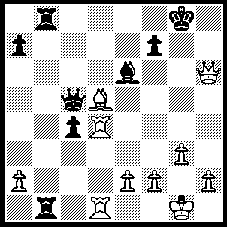
1.Rg4+ Bxg4, 2.Qg6+ Kh8, 3.Qf6+ Kh7 (3…..Kg8, 4.Bxf7+ Kf8 [4…..Kh7, 5.Qg6+ Kh8, 6.Qh6++], 5.Bxc4+ Ke8, 6.Qf7++), 4.Qxf7+ Kh8 (4…..Kh6, 5.Qf6+ Kh7, 6.Qh4+ as in game), 5.Qf6+ Kh7, 6.Qh4+ Kg7 (6…..Kg6, 7.Qxg4+ Kh6 [7…..Kh7, 8.Qh5+ Kg7, 9.Qg5+ Kf8, 10.Qf6+ Ke8, 11.Bf7+ Kf8, 12.Bxc4+ Ke8, 13.Qf7++ IF 7…..Kf6, 8.Qe6+ Kg7 [[8…..Kg5, 9.h4+ Kh5, 10.Bf3++]], 9.Qf7+ Kh6, 10.Be4 Rxd1+, 11.Kg2 Rd6, 12.Qh7+ Kg5, 13.Qh4++], 8.Qf4+ Kh7, 9.Qf7+ Kh6, 10.Be4 Rxd1, 11.Kg2 Rd6, 12.Qh7+ Kg5, 13.Qh4++ OR 6…..Bh5, 7.Qxh5+ Kg7, 8.Qg5+ Kh7[8…..Kf8, 9.Qf6+ Ke8, 10.Bf7+ Kf8, 11.Bxe4+ Ke8, 12.Qf7++], 9.Be4+ Kh8, 10.Qh6+ Kg8, 11.Bh7+ Kf7, 12.Bg6+ Ke6/f6 [12…..Ke7, 13.Qg7+ Ke6, 14.Qf7+ Ke5, 15.Qf5++], 13.Bh5+ Ke5 [13…..Kf5, 14.e4+ Ke5, 15.Qf4+ Ke6, 16.Qf7+ Ke5, 17.Qf5++ IF 13…..Ke7, 14.Qg7+ Ke6, 15.Bf7+ Kf5 [[15…..Ke7, 16.Bxc4+ Ke8, 17.Qf7++]], 16.Qg6+ Ke5, 17.Qe6++], 14.Qg7+ Kf5 [14…..Ke6, 15.Bf7+ Kf5, 16.Qg6+ Ke5, 17.Qe6++ IF 14…..Ke4, 15.Bg6+ Qf5, 16.Qd4++], 15.Bg4+ Ke4, 16.Qg6+ Qf5 [16…..Ke5, 17.Qe6++], 17.Qxf5++), 7.Qg5+ Kh7 (7…..Kf8, 8.Qf6+ Ke8, 9.Bf7+ Kf8, 10.Bc4+ Ke8, 11.Qf7++), 8.Be4+ Kh8, 9.Qh6+ Kg8, 10.Bh7+ Kf7, 11.Bg6+ Ke6 (11…..Ke7, 12.Qg7+ Ke6, 13.Bf7+ Kf5 [13…..Ke7, 14.Bxc4+ Ke8, 15.Qf7++], 14..e4+ Kxe4, 15.Qxg4+ Ke5, 16.Qf4++ OR 11…..Kf6, 12.Bh5+ Ke5 [12…..Ke7, 13.Qg7+ Ke6, 14.Bf7+ Kf5, 15.e4+ Kxe4, 16.Qxg4+ Ke5, 17.Qf4++], 13.Qg7+ Ke4 [13…..Kf5, 14.Bxg4+ Ke4, 15.Qg6+ Ke5, 16.Qe6++], 14.Qxg4+ Ke5, 15.Qg7+ Ke4, 16.Bg6+ Qf5, 17.Qd4++), 12.Bh5+ Ke5 (12…..Kf5, 13.Bxg4+ Kxg4 [13…..Ke4/5, 14.Qf4++], 14.Qg6+ Qg5, 15.f3+ Kh3, 16.Qh7+ Qh5, 17.Qxh5++ OR 12…..Ke7, 13.Qg7+ Ke6, 14.Bf7+ Kf5, 15.e4+ Kxe4, 16.Qxg4+ Ke5, 17.Qf4++), 13.Qg7+ Ke4 (13…..Ke6, 14.Bf7+ mates OR 13…..Kf5, 14.Bxg4+ Ke4, 15.Qg6 mates), 14.Qxg4+ Ke5, 15.Qg7+ Kf5 (15…..Ke4, 16.Bg6+ Qf5, 17.Qd4++), 16.Bg4+ Ke4, 17.Qg6+ Ke5, 18.Qf5++.

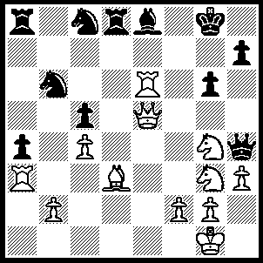
1.Nh5 Qxh5 (1…..Ra7, 2.Rxe8+ Kf7 [2…..Rxe8, 3.Qxe8++], , 3.Qe6++ OR 1…..gxh5, 2.Nh6+ Kf8, 3.Qh8++), 2.Nf6+ Kf7 (2…..Kf8, 3.Nxh5 gxh5/Ra7, 4.Qh8+ Kf7, 5.Rf6+ Ke7, 6.Qg7+ Bf7, 7.Qxf7++), 3.Nxh5 Ra7 (3…..Rd7, 4.Qg7+ Kxe6, 5.Qf6++ OR 3…..gxh5, 4.Qf5+ Kg7/8, 5.Qxh7+ Kf8, 6.Rf6+ Bf7, 7.Qxf7++),4.Bf5 gxf5/h5 (4…..Kf8, 5.Qh8+ Kf7, 5.Qg7++), 5.Qf6+ Kg8, 6.Rxe8+ Rxe8, 7.Rg3+ Rg7, 8.Qxg7++.
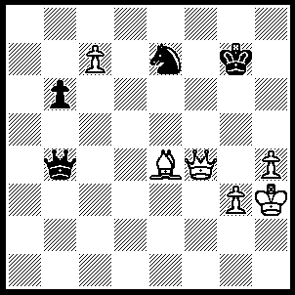
1.Qe5+ Kf8 (1…..Kh8, 2.c8(Q)+ Nxc8, 3.Qh6+ Kg8, 4.Bd5++ OR 1…..Kf7. 2.c8(Q) Nxc8, 3.Bd5+ Kg6 [3…..Kf8, 4.Qf6+ Ke8, 5.Bc6++], 4.Qg5+ Kh7, 5.Qxh5+ Kg7, 6.Qg5+ Kh7, 7.Qg8+ Kh6, 8.Bf7 Qb1, 9.Qh8+ Qh7, 10.Qf6+ Qg6, 11.Qxg6++) 2.Qf6+ Kg8 (2…..Ke8, 3.c8(Q)+ Nxc8, 4.Bc6++), 3.c8(Q)+ Nxc8, 4.Bd5+ Kh7, 5.Qf5+ Kg7 (5…..Kh6, 6.Qg5+ Kh7, 7.Qxh5+ as in game), 6.Qg5+ Kh7 (6…..Kf8, 7.Qf6+ Ke8, 8.Bc6++), 7.Qxh5+ Kg7, 8.Qg5+ Kh7, 9.Qg8+ Kh6, 10.Bf7 Qb1, 11.Qh8+ Qh7, 12.Qf6+ Qg6, 13.Qxg6++.

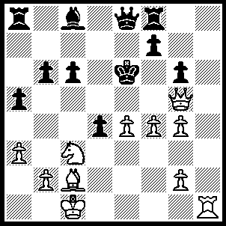
1.Nd5 f6 (1…..cxd5, 2.Qe5+ Kd7, 3.Ba4+ Kd8, 4.Bxe8 Rxe8, 5.Qxd5+ Ke7, 6.Qxa8 OR 1…..Kd6, 2.Nf6 Qe6 [2…..Qe7, 3.e5 Ke6 [[3…..Qxe5, 4.Qxe5++]], 4.Bb3++], 3.Bb3 c5 [3…..Qxb3, 4.Qe5++], 4.Bxe6), 2.Nxf6 Rxf6 (2…..Qd8/e7, 3.Qe5+ Kf7, 4.Rh7++), 3.Rh7 Rf7 (3…..Kd6, 4.Qxf6+ Kc5 [4…..Be6, 5.Qe5++ IF 4…..Qe6, 5.Qf8+ Qe7, 6.Qxe7++], 5.Re7 Qg8 [5…..Be6, 6.Qe5+ Kc4 [[6…..Bd5, 7.Rxe8 Rxe8, 8.Qxe8]], 7.Qxe6+ Kc5 [[7…..Kb5, 8.Bd3+ Kc5, 9.Qe5++]], 8.Qe5+ Kc4, 9.b3+ Kc3, 10.Qb5 cxb5, 11.Rc7+ Qc6, 12.Rxc6++], 6.b4+ Kb5 [6…..axb4, 7.Re5+ Qd5 [[7…..Kc4, 8.Qxc6++]], 8.Qe7+ Kb5 [[8…..Kc4, 9.Qxb4++]], 9.Bd3+ Ka5, 10.Qxb4++], 7.a4+ Kxb4 7…..Ka6, 8.Bd3+ b5, 9.Qxc6++], 8.Qd6+ Kc4 [8…..Kc3, 9.Qa3+ Kc4, 10.Bd3++], 9.Qxc6+ Kb4, 10.Qb5+ Kc3, 11.Qb2+ Kc4, 12.Rc7++),4.Bb3+ Kd6, 5.Rxf7 b5 (5…..Be6, 6.Qe5++ OR 5…..Qxf7, 6.Qe5+ Kd7, 7.Bxf7 c5, 8.Be8+ Kd8, 9.Bb5 Bxg4, 10.Qe8+ Kc7, 11.Qxa8), 6.Qf6+ Kc5 (6…..Qe6, 7.Qxd4+ Qd5, 8.Bxd5 Bd7, 9.Be6+ Kc7, 10..Rxd7+ Kb8/c8, 11.Qh8++), 7.Re7 Bd7 (7…..Qxe7, 8.Qxe7+ Kb6, 9.Qd8+ Kb7, 10.g5 d3, 11.f5 a4, 12.Be6 gxf5, 13.exf5 b4, 14.g6), 8.Qe5+ Kb6, 9.Qxd4+ Kc7, 10.Rxe8.

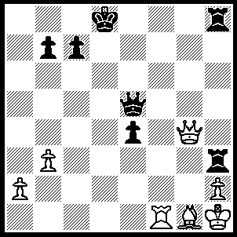
1.Rd1+ Ke7 (1…..Ke8, 2.Qd7+ Kf8, 3.Rf1+ Qf6, 4,Rxf6 Kg8, 5.Qf7++), 2.Bc5+ (2…..Ke8, 3.Qd7+ OR 2…..Kf6, 3.Rf1+ Qf5 [3…..Qf4, 4.Rxf4+ Ke5, 5.Qf5++], 4.Qxf5+ Kg7, 5.Qg5+ Kh7, 6.Rf7++ OR 2…..Qxc5, 3.Rd7+ Kf6, 4.Qg7+ Ke6, 5.Ke5, 6.Qf5++), 3.Rf1+ Qf6 (3…..Ke8, 4.Qc8++) , 4.Qd7+ Kg6 (4…..Kg8, 5.Rg1+ Qg6, 6.Rxg6++), 5.Rg1+ Qg5 (5…..Kh5, 6.Qg4+ Kh6, 7.Qxh3+ Qh4, 8.Qxh4++), 6.Qf5+ Kg7 (6…..Kh6, 7.Qxg5+ Kh7, 9.Qg7++), 7.Rxg5+ Kh6, 8.Qg6++.

