. KINGHUNT No.46
by Vern Stannard
Here is another batch to let you test your tactical vision.
Set your computer to play human v. human and allow you to take back moves. As you play through the positions and variations first see if you can work out the tactics behind white’s plans and of course white’s moves.

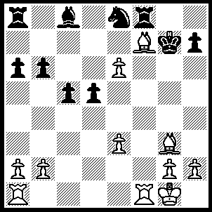
1.Be5+ Nf6 (1…..Kh6, 2.Rf4 Kg5 [2…..Bxe6, 3.Rh4+ Kg5, 4.Rh5+ Kg4,5.h3++ IF 2…..Rxf7, 3.exf7 Be6, 4.f8(Q)+ Kg6 [[4…..Ng7, 5.Rh4+ Kg6/5, 6.Qf6++ IF 4…..Kh5, 5.Rh4+ Kxh4, 6.Qh6+ Kg4, 7.R(a)f1 c4, 8.h3++]], 5.Rf6+ Nxf6, 6.Qxf6+ Kh5, 7.Bf4 h6, 8.Qxh6+ Kg4, 9.Qh3++], 3.h4+ Kh6, 4.Rf5 Rxf7 [4…..Ng7, 5.Bf4++], 5.exf7 Kg6, 6.f8(Q) Bxf5, 7.Qg8+ Ng7, 8.Qxg7+ Kh5, 9.Qg5++), 2.Rxf6 Rxf7 2…..Bxe6, 3.Rf5+ Kh6, 4.Rh5++ OR 2…..Ra7, 3.Rg6++), 3.Rxf7+ Kg6/h6 (3…..Kg8, 4.R(a)f1 Bxe6, 5.Rg7+ Kh8, 6.Rg6++), 4.R(a)f1 Ra7 (4…..h5, 5.h4 Bxe6, 6.R(1)f6++ OR 4…..h6, 5.Rg7+ Kh5, 6.Rf5+ Kh4, 7.Bf6++ OR 4…..Bxe6, 5.R(1)f6+ Kh5 [5…..Kg6, 6.Bf4+ Kh4/5 [[6…..Kg4, 7.Rg7+ Kh4/5, 8.Rh6++]] ,7.Rxh7+ Kg4, 8.h3++], 6.Rxh7+ Kg5 [6…..Kg4, 7.h3+ Kg5, 8.h4+ Kg4, 9.Rf4+ Kg3, 10.Re4++], 7.h4+ Kg4, 8.Rf4+ Kg3, 9.Re4++), 5.R(1)f6+ Kh5 (5…..Kg5, 6.Bg5+ Kh4/5 [6…..Kg4, 7.h3+ Kh5, 8.Rh6++], 7.Rh6+ Kg4, 8.h3++), 6.Rf5+ Kh4 (6…..Kh6, 7.Bf4+ Kg6, 8.Rg5+ Kh6, 9.Rf6++), 7.Bf6+ Kg4, 8.Rg5+ Kh4, 9.R(g)g7+ Kh5, 10.g4+ Kh6, 11.Bg5++.

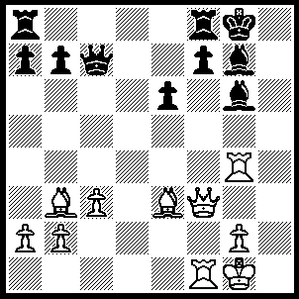
1.Rxg6 fxg6 (1…..Qe5, 2.Rg5 Qxg5 [2…..Qc7, 3.Qf6 Qe5, 4.Rxg7+ Kh8, 5.Qh6++], 3.Bxg5 R(a)c8 [4…..f6, 5.Qxe6+ Rf7, 6.Qxf7+ Kh7, 7.Qh5+ Bh6, 8.Qxh6++ IF 4…..f5, 5.Bxe6+ Rf7 [[5…..Kh7, 6.Qh5 mates], 6.Qxf5 Rc7/f8, 7.Bxf7+ Rxf7 [[7…..Kh8/7, 8.Qh3+ mates]], 8.Qxf7+ Kh8 [[8…..Kh7, 9.Bf6 mates]], 9.Rf6 a6, 10.Rh6+ Bxh6, 11.Bf6+ Bg7, 12.Qxg7++] , 4.Qg4 Rc4, 5.Bxc4 f5, 6.Bxe6+ Rf7 [6…..Kh7, 7.Qh5+ Bh6, 8.Qxh6++], 7.Qxf5 Bd4+ [7…..Kh8, 8.Qh3+ Kg8, 9.Bxf7+ Kf8, 10.Qc8++], 8.cxd4 Kh8, 9.Qxf7 a6, 10.Qg8++), 2.Bxe6+ Rf7 (2…..Kh7, 3.Qh3+ Bh6, 4.Qxh6++), 3.Bxf7+ Kf8 (3…..Qxf7, 4.Qxf7+ Kh7, 5.Kf2 Kh8, 6.Rh1+ Bh6, 7.Rxh6++), 4.Bxg6+ Ke7 (4…..Kg8, 5.Qd5+ Kh8 [5…..Qf7, 6.Bxf7 Kf8, 7.Bc5++], 6.Qh5+ Bh6 [6…..Kg8, 7.Qh7++] , 7.Bd4+ Kg8, 8.Qd5+ Qf7, 9.Qxf7++), 5.Qf7+ Kd6 (5…..Kd8, 6.Qe8++), 6.Bf4+ Kc6 (6…..Kc5, 7.Qxc7+ Kb5 [7…..Kd5, 8.Qd6+ Kc4, 9.Bd3++], 8.Qxb7+ Ka5 [8…..Kc5, 9.b4+ Kc4, 10.Qc6++], 9.Qb4+ Ka6, 10.Bd3++ OR 6…..Be5, 7.Bxe5+ Kxe5, 8.Qxc7+ Kd5, 9.Rd1+ Ke6, 10.Qd6++), 7.Qc4+ Kd7 (7…..Kb6, 8.Bxc7++), 8.Qxc7+ Ke6, 9.Qf7++.

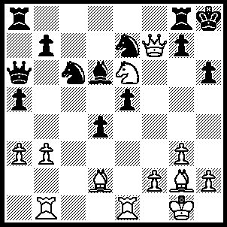
1.Bxh6 gxh6, 2.Be4 Ng6, 3.Bxg6 Rxg6, 4.Qxg6 Bf8, 5.Re4 Ne7 (5…..Qd3,6.Qf6+ Kh7, 7.Rg4 Qxb1+, 8.Kg2 Qe4+, 9.Rxe4 a4, 10.Rg4 axb3, 11.Qg6+ Kh8, 12.Qg8++), 6.Qf6+ Kh7, 7.Qf7+ Kh8, 8.Nxf8 Rxf8, 9.Qxf8+ Kh7 (9…..Ng8, 10.Rg4 Qg6, 11.Rxg6 d3, 12.Qxg8++), 10.Qf7+ Kh8, 11.Rg4 Ng6 (11…..Qg6, 12.Qf8+ Qg8 [12…..Kh7. 13.Qxe7+ Kh8, 14.Rg6 d3, 15.Qg7++], 13.Qxh6+ Qh7, 14.Qf6+ Qg7, 15.Qxg7++), 12.Rc1 Qc6 (12…..b5, 13.Rc7 d3, 14.Qg7++), 13.Rxc6 bxc6, 14.Rxg6 d3, 15.Qg7++.

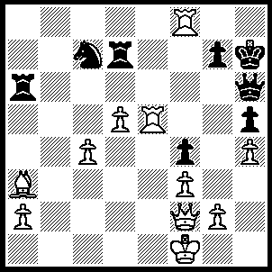
1.Qc2+ g6 (1…..Qg6, 2.Rxh5++ OR 1…..Rg6, 2.Qf5 Qg5 [2…..Rd6, 3.Qc8 R(g)f6, 4.Rh8+ Kg6, 5.Rxh6+ Kxh6 [[5…..gxh6, 6.Qg8++]], 6.Qh8+ Kg6, 7.Qxh5++], 3.hxg5 Rd8 [3…..h4, 4.Qxf4 R(d)d6, 5.Bxd6 Rxd6, 6.Qxh4+ Kg6 [[6…..Rh6, 7.g6+ Kxg6, 8.Qe4++]], 7.g4 Rxd5, 8.Qh5++], 4.Rxd8 h4, 5.Qf7 Rf6, 6.Qh5+ Rh6, 7.g6++), 2.Rxh5 Qxh5, 3.Qb2 Rg7 (3…..g5, 4.Qh8+ Kg6, 5.Rg8+ Kf5 [5…..Kf7, 6.Qg7++], 6.Bb2 Re7 [6…..Qxh8, 7.Rxg5++ IF 6…..Rb6, 7.Qe5++], 7.Qxh5 Re1+, 8.Kxe1 Re6+, 9.Kf1 Re1+, 8.Kxe1 Nxd5, 11.Qg6++), 4..Qb8 g5, 5.Rh8+ Kg6, 6.Qb1+ Kf6 (6…..Kf7, 7.Rf8++), 7.Qb2+ Kg6, 8.Qc2+ Kf6, 9.Qc3+ Kf6, 10.Qd3+ Kf6, 11.Qd4+ Kf7,12.Rf8+ Kg6,13.Qd3+ Kh6,14.Rh8+ Rh7, 15.Qxh7++.

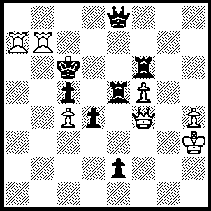
1.Qf3+ Re4 (1…..Kd6, 2.Ra6++), 2.Rg7 Kd6 (2…..Rf7, 3.Rg6+ Rf6, 4.Rxf6+ Qe6, 5.Rxe6++ OR 2…..Kb6, 3.Qb3+ Kc6, 4.Ra6++ OR 2…..Qf7, 3.Qxe4+ Kb6 [3…..Kd6, 4.Rgxf7 Rxf7, 5.Qe6++], 4.R(a)xf7 Rxf7, 5.Rxf7 Ka5, 6.Qb1 e1(Q), 7.Qb5++), 3.Qg3+ Re5, 4.Ra6+ Qc6, 5.Rxc6+ Kxc6, 6.Qxe5 Rf7, 7.Rxf7+ Ka8, 9.Qc8++.

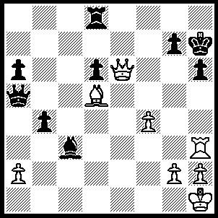
1.Be4+ Kh8 (1…..g6, 2.Qxg6+ Kh8, 3.Qh7++ OR 1…..Qf5, 2.Bxf5+ Kh8, 3.Rxh6+ gxh6, 4.Qxh6+ Kg8, 5.Be6++), 2.Qf7 Qc7, 3.Qxc7 Kg8 (3…..Ra8, 4.Rxh6+ Kg8, 5.Bd5+ Kf8, 6.Qf7++), 4.Qxd8+ Kf7, 5.Bd5+ Kg6, 6.Qe7 Kf5 (6…..Kh7, 7.Be4+ Kg8, 8.Qe8++ OR 6…..h5, 7.Qf7+ Kh6/7, 8.Rxh5++ OR 6…..a5, 7.Be4++), 7.Qe4+ Kf6 (7…..Kg4, 8.Be6++), 8.Qe6++.

