KINGHUNT No.47
by Vern Stannard
Here are more positions to help you improve your ability to see through the complexities that can arise when attacking your opponent’s king. As you examine each of the many possible ways black can try and defend see if you can work out white’s next move and why.
As usual some variations stop after a big material win by White
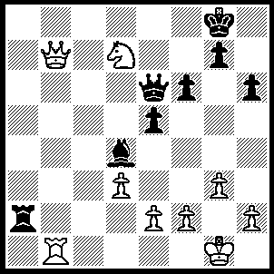
1.Qc8+ Kf7, 2.Rb8 Qe7 (2….Ra1+, 3.Kg2 Qd5+, 4.e4 Qe6, 5.Qg8+ Kg6, 6.Nf8+ Kh5, 7.Qxe6 Rg1+ [7…..Ra7, 8.Qh3+ Kg5, 9.Qh4++], 8.Kh3, f5, 9.Qxf5 g5, 11.Qf7++ OR 2…..Ra6, 3.Qg8+ Ke7 [3…..Kg6, 4.Nxf8+ Kh5, 5.Nxe6 Ra1+, 6.Kg2 Ra7, 7.Nxg7+ Kg5, 8.Ne8+ Kf5 [[8…..Kh5, 9.Nxf6++]], 9.e4++], 4.Qf8+ Kxd7, 5.Qc8+ Kd6, 6.Qxa6+ Ke7, 7.Re8+ Kxe8, 8.Qxe6+ Kf8, 9.e3 Ba8, 10.Qa6 Ba7, 11.Qb7+ Kg6, 12.Qxb2),
3.Qg8+ Kg6, 4.Nf8+ Qxf8 (4…..Kf5, 5.Qh7+ Kg4, 6.h3+ Kxh3 [6…..Kg5/h5, 7.Qg6++], 7.Qf5++ OR 4…..Kh5, 5.Qh7 Qxf8 [5…..Qf7, 5.Qf5+ g5, 6.Qh3++], 6.Qf5+ g5, 7.g4+ Kh4, 8.Qf3 Ra1+, 9.Kg2 Rg1+, 10.Kxg1 Bxf2+, 11.Kg2 Qxb8, 12.Qh3++ OR 4…..Kg5, 5.Qh7 Qf7 [5…..Qxf8, 6.Rxf8 Ra7, 7.h4+ Kg4, 8.Qg6+ Kh3, 10.Qf5++], 6.h4+ Kg4, 7.Qe4+ Kh5 [7…..Kh3, 8.Qf5++], 8.Qf3++),
5.Rxf8 Ra7 (5…..Kf5, 6.Qxg7 Ke6, 7.Rxf6+ Kd5, 8.Qg8+ Kc5, 9.Qc4++ OR 5…..Bc5, 6.Qf7+ Kh7 [6…..Kf5, 7.e4+ Kg5, 8.h4+ Kg4, 9.Qg6+ Kf3, 10.Qh5++], 7.Rg8 Bf8, 8.Qxf8 Ra7, 9.Qe8 Rf7, 10.Qxf7 e4, 11.Qxg7++),
6.Qe6 h5 (6…..Kh7, 7.Qf5+ g6, 8.Qc8 Kg7, 9.Rg8+ Kf7, 10.Qe8++ OR 6…..Ra1+, 7.Kg2 Ra7, 8.Qg4+ Kh7, 9.Qf5+ g6, 10.Qc8 mates OR 6…..Kg5, 7.e4 h5 [7…..g6, 8.Qxf6+ Kg4/h5, 9.Qh4++], 8.Qf5+ Kh6, 9.Rh8++),
7.Qe8+ Kg5 (7…..Kg5, 8.h4+ Kf5, 9.e4+ Kg4, 10.Qg6+ Kf3, 11.Qxh5++ OR 7…..Kf5, 8.e4+ Kg5, 9.h4+ Kg4, 10.Qg6+ Kh3, 11.Qf5++ OR 7…..Kh6, 8.Rh8+ Kg5, 9.Qxh5++ OR 7…..Kh7, 8.Qxh5++),
8.h4+ Kf5 (8…..Kg4, 9.Qg6+ Kh3, 10.Qf5++),
9.e4+ Kg4, 10.Qg6+ Kf3, 11.Qxh5++.

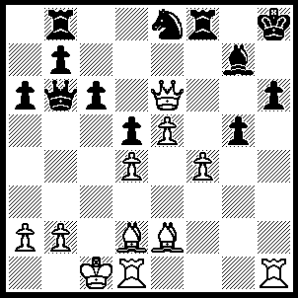
1.Rxh6+ Bxh6, 2.Qxh6+ Kg8, 3.Rh1 Qc7 (3…..Rxf4, 4.Qh8+ Kf7, 5.Rh7+ Ke6 [5…..Ng7, 6.Qxg7+ Ke6, 7.Qd7++ IF 5…..Kg6, 6.Bd3+ Rf5, 7.Qf7++], 6.Qg8+ Rf7 [6…..Kf5, 7.Bd3+ Kg4 [[7….Re5, 8.Qxg5+ Ke6, 9.Re7++]], 8.Qed6+ Kg3 [[8…..Rf5, 9.Qxf5+ Kg3, 10.Be1+ Kg2, 11.Qf1++]], 9.Qh3+ Kf2, 10.Be1+ Kg1 [[10…..Kxe1, 11.Qf1++]], 11.Qh1++], 7.Qxf7++),
4.Qh8+ Kf7, 5.Rh7+ Ke6 (5…..Kg6, 6.Qxf8+ gxf4 [6…..Qxh7, 7.f5++ IF 6…..Ng7, 7.Bd3+ Nf5, 8.Qxf5++ IF 6…..Kxh7, 7.Bd3++], 7.Bd3+ Kg5, 8.Qf5++),
6.Bg4+ Rf5, 7.Qg8+ Qf7, 8.Qxf7++.

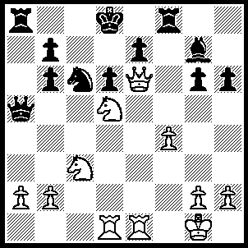
1.b4 Qa3 (1…..Bxa3, 2.Nxe7 Bxb4 [2…..Nxe7, 3.Qxe7+ Kc8, 4.Qxf8+ Kc7, 5.Qxd6+ Kc8, 6.Qd8++], 3.Nxc6+ Kc7 [3…..bxc6, 4.Qe7+ Kc8, 5.Qxf8+ Kb7, 6.Re7+ Ka6, 7.Qa8+ Kb5, 8.Ra7], 4.Nxa5 Bc5+, 5.Kh1 R(f)d8,, 6.Qd5 Rxa5, 7.Re7+ Rd7, 8.Rxd7+ Kxd7, 9.Re1 Ra7, 10.Qf7+ Kc6, 11.Qe8+ Kd5, 12.Qe4++), 2.Nxe7 Bd4+ (2…..Qxb4, 3.Rxd6+ Kc7 [3…..Qxd6, 4.Qxd6+ Ke8, 5.Nxc6+ Kf7, 6.Qe6++], 4.Rd7+ Kb8, 5.Nxc6+ bxc6, 6.Qe8+ Rxe8, 7.Rxe8++ OR 2.Nxe7, 3.Qxe7+ Kc8, 4.Nb5 Bd4+, 5.Rxd4 Qe3+, 6.Rxe3 Rxa2, 7.Qc7++), 3.Rxd4 Qxc3 (3…..Nxe7, 4.Qxe7+ Kc8, 5.Qxf8+ Kc7, 6.Qxd6+ Kc8, 7.Qd8++), 4.Qxd6+ Ke8, 5.Qd7+ Kf7, 6.Qe6+ Kg7 (6…..Ke8, 7.Nxc6++), 7.Qxg6+ Kh8, 8.Qxh6++.

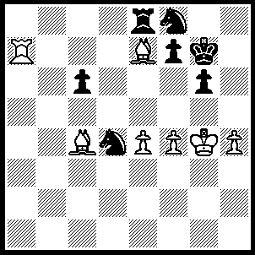
1.Bf6+ Kg8 (1…..Kxf6, 2.Rxf7++ OR 1…..Kh6, 2.Rxf7 N(f/d)e6, 3.Bg5+ Nxg5, 4.hxg5++ OR 1…..Kh7, 2.Rxfd7+ Kg8, 3.Rg7+ Kh8, 4.Re7++), 2.Bxf7+ Kh7, 3.Bxe8+ Kg8 (3…..Nd7, 4.Rxd7+ Kg8, 5.Bf7+ Kf8, 6.Bc4 Ne6, 7.Bxe6 c5, 8.Rd8++), 4.Bf7+ Kh7, 5.Be6+ Nd7, 6.Rxd7 Kh6, 5.Bg5++.

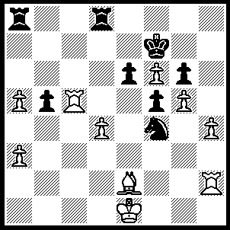
1.Rc7+ Kf8, 2.h5 Rxd4 (2…..Rxa3,3.hxg6 Nxg6, 4.Rh(h)7 e5 [4…..Rxa3, 5.R(c)f7+ Kg8 [[5…..Ke8, 6.Bxb5+ Rd7, 7.Rxd7 Ra8 {{7…..e5, 8.Rd6+ Kf8, 9.Rd8++}}, 8.Ra7+ Kd8, 9.Rxa8++]], 6.R(fg7+ Kf8, 7.Rxg6 e5, 8.R(g)g7 Ra1+, 9.Kf2 exd4, 10.Rh8++], 5.Bh5 Rxa3, 6.Bxg6 Ra1+, 7.Kd2 Rxd4+, 8.Kc2 Rc4+ [8…..Ra2+ 9.Kb1], 9.Rxc4 bxc4 [9…..Ra8, 10.Rh8++], 10.Rh8++ OR 2…..Nxh5, 3.Bxh5 Rxd4 [3.R(a/d)c8, 4.Bxg6 Kg8, 5.Bf7+ Kf8, 6.Rh8++ IF 3…..gxh5, 4.Rxh5 Kg8, 5.Rg7+ Kf8, 6.Rh8++], 4.Bf3 Rh4, 5.Rxh4 mates),
3.hxg6 Nxg6, 4.Rh6 Rh4 (4…..Re4, 5.Rxg6 Rh4, 6.R(g)g7 Rh1+, 7.Kf2 Rd8, 8.R(c)f7+ Ke8, 9.Bxb5+ Rd7, 10.Rxd7 Rh2+ 11.Kg3 f4+ 12.Kxh2 f3, 13.Rg8++ OR 4…..R(a)d8, 5.R(c)h7 e5, 6.Rxg6 R(4)d7, 7.R(g)h6 Rxh7, 8.Rxh7 Kg8 [8…..Rd6, 9.Bh5 Kg8, 10.f7+ Kxh7, 11.f8(Q) IF 8…..Rb8, 9.g6 Kg8, 10.Bd1 Rc8, 11.Bb3+ Rc4, 12.Rd7 b4, 13.Rd8++], 9.g6 e4, 10.Bxb5 Rc8, 11.Re7 Kf8,12.g7+ Kg8, 13.Bc4+ Rxc4, 14.Re8+ Kh7, 15.g8(Q)+),
5.Rxg6 Rh1+ 6.Kf2 Rd8 6…..Rh2+ 7.Kg1 Rh8 [Rxe2, 8.f7 e5, 9.Rg8++], 8.R(g)g7 Rd8 [8…..Rb8, 9.Bxb5 RxB5, 10.Rc8++], 9.R(c)f7+ Ke8, 10.Bxb5+ Rd7, 11.Rxd7 mates),
7.R(g)g7 Rh2+, 8.Kf1 Rh1+ (8…..Rxe2, 9.g6 b4, 10.R(c)f7+ ke8, 11.Rg8++), 9.Kg2 Rh4 (9…..Rh8, 10.R(c)f7+ Ke8, 11.Bxb5+ Rd7, 12.Rxd7mates), 10.R(c)f7+ Ke8, 11.g6 Rh8, 12.Bxb5+ Rd7, Rh2+, 14.Kxh2 f4, 15.Rg8++.

