KINGHUNT No.48
by Vern Stannard
Here are more positions to help you improve your ability to see through the complexities that can arise when attacking your opponent’s king. As you examine each of the many possible ways Black can try and defend see if you can work out White’s next move and why.

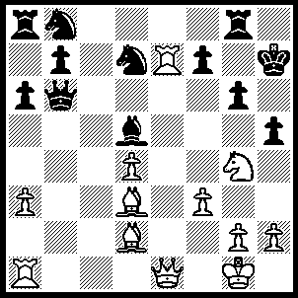
1.Qe3 Rc8 (1…..Rf8, 2.Ba5 Qd6 [2…..Qxa5, 3.Qh6+ Kg8, 4.Bxg6 Rc8, 5.Qh7+ Kf8, 6.Qxf7+ Ke8, 7.Qh8+ Nf8, 8.Qxf8++], 3.Bc7 Qxe7 [3….Qc6, 4.Rc1 Rxg4, 5.Rxc6 bxc6, 6.Qg5 Kg8 [[6…..gxf3, 7.Qxg6+ Kh8, 8.Qh7++]], 7.Bxg6 Rc8, 8.Bxd5 Rxc7, 9.Qg7++ OR 3…..Qxc7/Qxa3, 4.Qh6+ Kg8, 5.Bxg6 Nf6, 6.Nxf6++), 4.Bxg6+ Kxg6 4…..fxg6, 5.Qxe7+ Kg8 [[5…..Kh8, 6.Be5+ Nxe5, 7.Qxf8+ Bg8, 8.Qh6+ Bh7, 9.Nf6 h4, 10.Qxh7++}}, 6.Nh6 Kh8, 7.Be5+ Nxe5, 8.Qxf8+ Kh7, 9.dxe5 IF 4…..Kg8, 5.Qxe7 Nc6 [[5…..fxg6, 6.Nh6+ Kh8, 7.Be5+ Nxe5, 8.Qxf8+ Kh7, 9.dxe5]], 6.Qg5 fxg6, 7.Qxg6+ Kh8, 8.Qxh5+ Kg7, 9.Qh6+ Kg8. 10.Qh7+ Ke8 [[10…..Ke6, 11.Re1+ N(d)e5, 12.Nxe5 Be4, 13.Rxe4 Ne7, 14.d5+ Kf6, 15.Nds7+ Kg5, 16.h4++]], 11.Re1+ N(d)xe5, 12.Nxe5 Rf7, 13.Nxc6+ Kd7, 14.Re7+ Kc8, 15.Qg8+ Rf8, 16.Qxf8++], 5.Qh6+ Kf5, 6.Qxh5+ Qg5, 7.Ne3+ Kf6, 8.Nxd5+ Qxd5, 9.Qxd5 a5, 10.Rb1 Ra6, 11.Rb5),
2.Re1 Rf8 (2…..Nf6, 3.Qh6+ Kg8, 4.Nxf6+ Qxf6, 5.Re8+ Rxe8, 5.Rxe8++ OR 2…..Nc6, 3.Bxg6+ Kg8 [3…..Kxg6, 4.Qh6+ Kf5, 5.Ne3++], 4.Bxf7+ Kf8/h8, 5.Qh6++),
3.Ba5 Qd6 (3…..Qxa5, 4.Bxg6+ Kg8 [4…..Kxg6, 4.Qh6+ Kf5, 5.Ne3++], 5.Nh6+ Kg7 [5…..Kh8, 6.Nxf7+ Rxf7 [[6…..Kg8, 7.Nh6+ Kh8, 8.Rh7++]], 7.Qh6+ Kg8, 8.Re1+ Nf8, 9.Rxf8+ Rxf8, 10.Qh7++], 6.Nf5+ Kf6 [6…..Kg8, 7.Bxf7+ Rxf7, 8.Qg5+ Kh8 [[8…..Kh7, 9.Rxf7+ Kh8, 10.Qg7++]], 9.Re8+ Nf8 , 10.Rxf8+ Rxf8, 11.Qg7++], 7.Qh6 Qxe1+ [7…..fxg6, 8.Qg7+ Kg5, 9.h4+ Kf4 [[9…..Kxf5, 10.R(1)e5+ Kf4 [10…..Nxe5, 11.Qxe5++], 11.Qh6+ g5 [11…..Kg3, 12.Qg5++], 12.Qxg5++ IF 7…..Ne5, 8.dxe5++ IF 7…./.Nc6/Rh8, 8.Bh7++] 8.Rxe1 fxg6 [8…..Ne5, 9.Bxf7+ Kxf7, 10.Qg7+ Ke6, 11.Rxe5++], 9.Qg7+ Kg5 [9…..Kcf5, 10.Re5+ Kf4 [[10…..NBxg5, 11.Qxe5++]], 11.Qh6+ g5, 12.Qxg5++], 10.h4+ Kxf5 [10…..Kf4, 11.Qh6+ Kxf5, 12.Qg5++], 11.Re5+ Kf4, 12.Qh6+ g5 [12…..Kg3, 13.Qg5++], 13.Qxg5++ OR 3…..Qc6, 4.Qh6+ Kg8, 5.Re8 Qd6, 6.Bb4 Nc6, 7.Bxd6 R(f)xe8, 8.Rxe8+ Rxe8, 9.Bxg6 Re1+, 10.Kf2 fxg6, 11.Qxg6+ Kh8, 12.Nf6 Nxf6, 13.Qxf6+ Kh7, 14.Kxe1),
4.Qh6+ Kg8, 5.Bc7 hxg4 (5…..Qxc7, 6.Bxg6 Nf6, 7.Nxf6++ OR 5…..Qxa3, 6.Be5 Nf6, 7.Nxf6++ OR 5…..Qc6, 6.Re8 f5, 7.Be5 Kf7, 8.Bd6 Kg8 [8…..Rxe8/Qxd6, 9.Qh7++], 9.Rxf8+ Nxf8, 10.Qxf8+ Kh7, 11.Nf6++),
6.Bxd6 gxf3 (6…..Nc6, 7.Bxg6 Nf6, 8.Bf5 Ne5 [8…..R(a)e8, 9.Rxe8 Rxe8, 10.Rxe8+ Nxe8, 11.Qh7++ IF 8…..Nxe7, 9,Bxe7 gxf3, 10.Bxf6 f2+, 11.Kxf2 Bxg2, 12.Qh8++], 9.R(7)xe5 Be6, 10.Qg5+ Kh8, 11.Qxf6+ Kg8, 12.Bh7+ Kxh7, 13.Rh5+ Kg8, 14.Qh8++),
7.Bxg6 f2+ (7…..Nf6, 8.R(7)e4 f2+, 9.Kxf2 N(b)d7, 10.Bh7+ Kf8 [10…..Nxh7, 11.Rg4+ Ng5, 12.Rxg5++], 11.Bf5+ Kg8, 12.Qg5+ Kh8, 13.Rh4+ Nh7, 14.Rxh7++),
8.Kxf2 Nf6, 9.R(7)e4 N(b)d7 (9…..Bxe4, 10.Qxf8++), 10.Bh7+ Kh8 (10…..Nxh7, 11.Rg4+ Kh8, 12.Qg7++), 11.Bf5+ Kg8, 12.Qg5+ Kh8, 13.Rh4+ Nh7, 14.Rxh7++.

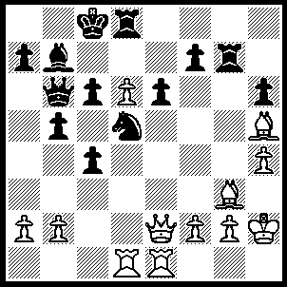
1.Qe5 Rh7 (1…..Rxg3, 2.Qxg3 Qc5, 3.Bxf7 Qxd6, 4.Bxe6+ OR 1…..Rg8, 2.d7+ Kxd7 [2…..Rxd7, 3.Qb8++], 3.Bxf7 Rxg3 [3…..Ke7, 4.Qxe6+ Kf8, 5.Bd6+ Kg7 [[5…..Rxd6, 6.Qe8+ Kg7, 7.Qxg8+ Kf6, 8.Qg6++]], 6.Qg6+ Kh8, 7.Qxh6++], 4.Bxe6+ Ke8, 5.Bxd5+ Kd7, 6.Be6+ Ke7/8, 7.Bxc4+ Kf8, 8.Qe7++), 2.d7+ Kxd7, 3.Bxf7 Ke7 (3…..Kc8, 4.Bxe6+ R(7/8)d7, 5.Qb8++), 4.Qxe6+ Kf8, 5.Bd6+Kg7 (5…..Rxd6, 6.Qe8+ mates), 6.Qg6+ Kh8, 7.Be5+ Nf6, 8.Bxf6+ Rg7, 9.Qxg7++.

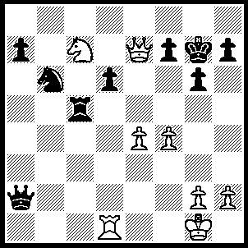
1.Ne8+ Kg8, 2.Qf6 Kf8, 3.Nxd6 Nd7 (3…..Rc2, 4.Qh8+ Ke7, 5.Qe8+ Kf6, 6.Qe5++ OR 3…..Nc8, 4.Nf5), 4.Qh8+ Ke7, 5.e5 Nxe5 (5…..Rxe5, 6.fxe5 Nxe5, 7.Qxe5+ Kf8, 8.Qh8+ Ke7, 9.Nf5+ Ke6 [9…..gxf5, 10.Qd8+ Ke6, 11.Qd6++], 10.Rd6+ Kxf5, 11.Qf6+ Ke4, 12.Rd4+ Ke3, 13.Qe5++ OR 5…..Rc8, 6.Nxc8+ Ke6, 7.g4 mates OR 5…..Ke6, 6.Qe8++), 6.fxe5 Kd7 (6…..Qa4, 7.Nf5+ gxf5, 8.Qd8+ Ke6, 9.Qd6++ OR 6…..Rxe5, 7.Nc8+ Ke6, 8.Rd6+ Kf5, 9.Qf6+ Kg4, 10.Rd4+ Re4, 11.Rxe4+ Kh5, 12.Rh4++ OR 6…..Rc8, 7.Nxc8+ Ke6, 8.Qf6++), 7.Qe8+ Kc7, 8.Qc8+ Kb6, 9.Qb7+ Ka5, 10.Qxa7+ Kb4, 11.Qxa2 Rc3 (11…..Rxe5, `12.Qb2+ 13.Qb5++ OR 11…..Kc3, 12.Ne4+ Kb4, 13.Rb1++), 12.Qb2+ Rb3, 13.Qd4+ Ka5, 14.Ra1+ Ra3, 15.Rxa3++.

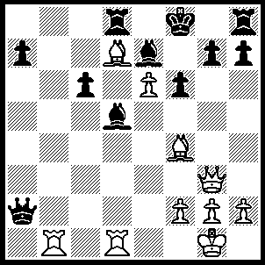
1.Bd6 Qa5 (1…..Qa4, 2.Bxe7+ Kxe7, 3.Rxd5 OR 1…..Bxd6, 2.Qxd6+ Kg8, 3.Rb5 h5, 4.Rxd8+ Kh7, 5.Rxh8+ Kxh8, 6.e7), 2.Bxe7+ Kxe7, 3.Rb7 Rb8, 4.Rc7 Qxc7 (4…..R(h)g8, 5.Bc8+ Ke8, 6.Qd6 Qxc7, 7.Bd7+ Kd8, 8,e7++ OR 4…..Bxe6, 5.Qd6+ Kf7, 6.Be8+ Kxe8, 7.Qe7++ OR 4…..Qd2, 5.Bc8+ Ke8,6.Re7+ Kxe7, 7.Qc7+ Ke8, 8.Qf7+ Kd8, 9.Qd7++), 5.Qxc7 Rb7, 6.Qxb7 Rb8, 7.Qc7 Rb7, 8.Qxb7 Kd6, 9.Qxc6+ Ke5, 10.Qxd5+ Kf4, 11.Rd4++.
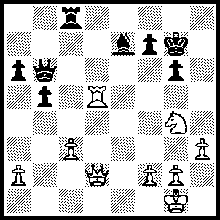
1.Qh6+ Kg8, 2.Rh5 f5 (2…..gxh5, 3.Qxb6 OR 2…..f6, 3.Qxg6+ Kf8, 4.Rh8++), 3.Qh8+ Kf7, 4.Rh7+ Ke6, 5.Qe5+ Kd7, 6.Qxe7+ Kc6, 7.Qd7+ Kc5, 8.Qd4+ Kc6, 9.Ne5++.

