CHESS November 04, 2023 David Ellis 0439798607 / ellisd19@bigpond.com

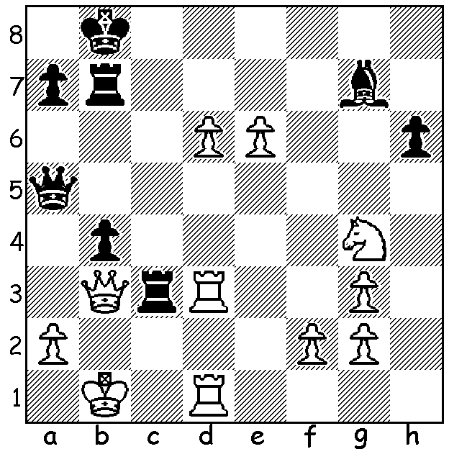

Vladimir Kramnik vs Erwin l’Ami
(Isle of Man 2017) White appears to have
his queen trapped: is there an escape?

UK GIRL WORLD CHAMPION
British chess sensation Bodhana Sivanandan scored 10/10 to become England’s first youth champion in 25 years by winning the Girls World Under 8 championship, held in Egypt. She had earlier in the year won the Girls Under 8 world championships in Rapidplay and Blitz, repeating her successes of 2022. This year she also won the UK Womens Blitz championship. In June ChessBase India called her the most talented eight-year-old in the world. Her ambition is to become the youngest GM (Grandmaster) ever. She is considered to have an extremely good understanding of endgame technique, something surprising for someone so young.

FIDE GRAND PRIX, ISLE OF MAN
The 2023 FIDE GRAND PRIX (25 Oct – 5 Nov), being played in the holiday resort and capital of the Isle of Man, Douglas, can be considered the most important Swiss tournament of the year with the top two placed players qualifying for the eight-player 2024 Candidates to find a challenger to world champion Ding Liren. The tournament has, at time of writing, progressed to Rd 6 with eight players, including top ranked players Fabiano Caruana and Hikaru Nakamura (both US), level first with 4.5. WA’s Australian champion Temur Kuybokarov lost his first game in Rd 6, beaten by four times Ukranian champion Anton Korobov who sacrificed his queen on move 11 for rook and bishop and an enduring positional advantage. Temur now has 3/6 (+1 =4 -1).

SOLUTION: White cannot play 1.Qb2 (1...Rxd3) nor 1.Rxc3 (1…bxc3 2.d7 Rxb3+ 3.axb3 c2+! 4.Kxc2 Qc3+ 5.Kb1 Qb2#). Instead he plays 1.d7! and wins (1…Rxb3+ 2.Rxb3 Qd8 3.e7! and Black resigns).

