CHESS 10 Feb, 2024 David Ellis 0439798607 / ellisd19@bigpond.com

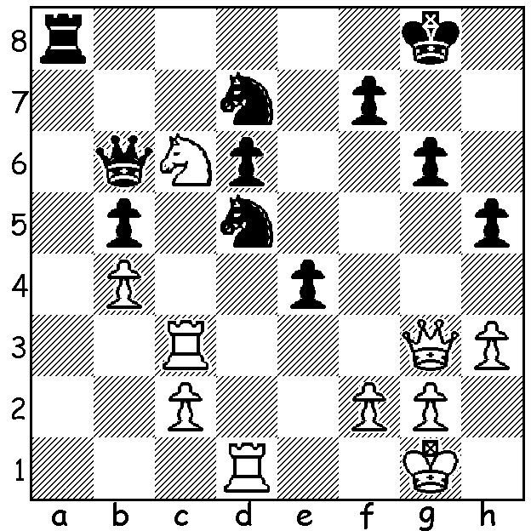

[DIAGRAM HERE]
Prraneeth Vappala vs
Leon Mendonca, 2023
Black’s surprise move
gains a material plus:

ANOTHER COME FROM BEHIND VICTORY
The Challengers at the Tata Steel event in Wijk aan Zee followed a similar pattern to the main tournament won by 24 year-old Chinese GM Wei Yi who scored 4.5 from his last 5 games. The come from behind Challengers’ victory by 17 year-old Indian GM Leon Luke Mendonca was even more remarkable with the young Indian scoring 6.5 from his final 7 games to finish on 9.5/13, a half point ahead of 16 year-old French GM Marc Maurizzi, who last year became World Junior Champion. Maurizzi had led through most of the tournament and entered Round 12 a point ahead of Mendonca but a loss and then a Round 13 draw enabled Mendonca to leapfrog him into first place. This is just one of the many recent tournament successes by Mendonca, another of the young Indian stars.

The SOUTHERN SUBURBS OPEN, a seven-round event open to players from other clubs as well as newcomers wanting to play tournament chess, will start on Tuesday 13 February.

The 2024 PERTH INTERNATIONAL OPEN will be played March 1-4 at the Rendezvous Hotel, Scarborough. It will have three sections, catering for all standards of play, from near beginners to Grandmasters. Get your entry in before February 23 for early bird reduction.
Details of these and other events see cawa.or.au

SOLUTION: Black is not satisfied with regaining the exchange with 1…Nxc3 but plays 1…e3!!, an interruption sacrifice, removing the queen’s protection of the c3 rook; if 2.fxe Nxc3 and if 2.Rxd5 exf+ 3.Qxf2 Ra1+, winning the queen. White played 2.Ne7+ but after 2…Nxe7 3.Qxe3 Qxe3 4.fxe3 Nf6 Black with two knights for a rook soon won.

