CHESS 2 March, 2024 David Ellis ellisd19@bigpond.com 043979860
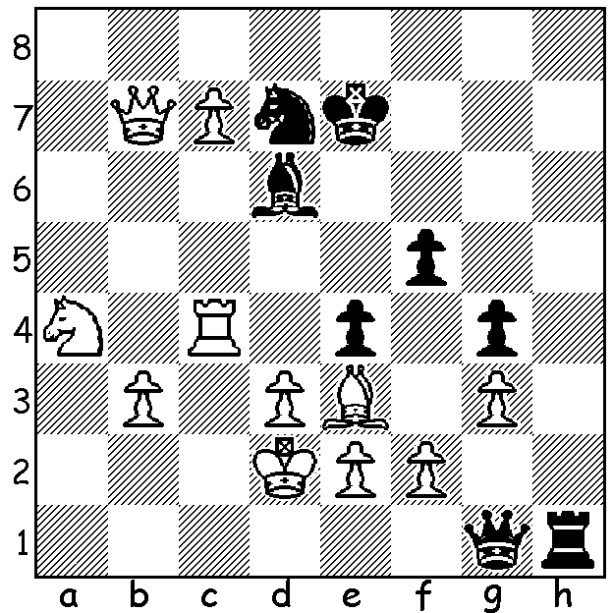

Levon Aronian vs
Nodirek Abdusattorov
(GOAT Challenge 2024):
White eliminates Black’s
threats and wins.

IS FISCHER RANDOM THE FUTURE OF CHESS?
The success of the Freestyle GOAT Challenge, played in Germany and won by World No. 1 Magnus Carlsen, has had some wondering if this is the future of Chess. The Freestyle or Fischer Random or 960 Chess (960 so called for the total number of possible starting positions) certainly has a number of advantages over the traditional starting position. With the pieces randomly placed on the back ranks (bishops must be on opposite coloured squares, normal castling is possible and Black mirrors White as in normal chess) players cannot rely on learned opening moves (sometimes up to 30 moves) but have to think creatively from move 1 (Carlsen called the event exhausting). The final round had the following starting position – NNRKBBRQ with players able to play 1.0-0-0. Interestingly the players were given 10 mins to look at the position before a game and could study the position in collaboration or by themselves. Players in the lead could not attempt to go into positions that regularly result in draws and 70% of games were decisive. This was the first 960 tournament which used Classic time controls (though games before the KO finals were Rapidplay) and there are thoughts of future Fisher Random World Championships.

Players discussing starting position
before game. Note the distinctive
individually coloured jacket of each
player. Another innovation was the
prize monies were in $20 bills.

KASPAROV ON NAVALNY: Former world champion and a one-time intended presidential opponent to Putin, Garry Kasparov, declared, ‘Putin tried and failed to murder Navalny quickly and secretly with poison and now he has murdered him slowly and publicly in prison’ and described Navalny’s voluntary return to Russia as ‘an act of heroism’.

SOLUTION: Certainly not 1.c8=Q?? which loses to 1…Qe1+ (can you find the mate?). Instead White employs the theme of SIMPLIFICATION and sacrifices his queen – 1.Rxe4+! (1.Bg5+/2.c8=Q should also win but allows a number of worrying checks) 1…fxe4 2.Qxe4+ Ne5 3.Qxh1! Bb4+ 4.Kc2 Qxh1 5.c8=Q (4 pawns up and the attack).

