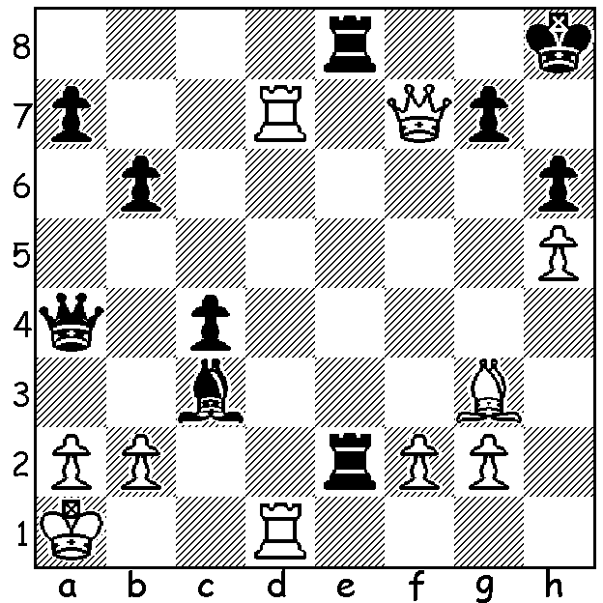

**Tony Miles vs Craig Pritchett 1982**

White wins with a surprise move: *Tony Miles*

**CHESS ON BBC TV**

I recently read of a 2025 TV series shown on BBC called Chess Masters, compered by

Celebrity Sue Perkins assisted by chess coach Anthony Mathurin and three-times British champion David Howell. Twelve talented amateurs were pitted against each other in rapidplay and problem solving. A quote from Sue Perkins; “It’s all about psychology, strategy, smart thinking and nerves of steel. … I’m there to help understand what’s going on in the players’ minds and make sense of what’s happening on the board. We’ve been waiting over thirty years to see chess on our TV again.’

She was referring to the then ground-breaking series called The Master Game shown yearly between 1975 and 1984, A knock-out tournament played under normal time controls with expert

analysis, its winners included some of the greatest international players such as Bent Larsen and world champion Anatoly Karpov as well as prominent English players Bill Hartson (twice), Nigel Short and Tony Miles. Miles’ success came in the final series, 1983-84, when he defeated Karpov who had beaten him in the 1977-78 final. Unfortunately for the British chess public, it was not broadcast due to a TV technicians’ strike although it was dubbed and shown on German TV.

I imagine the recent series would have had a sizeable audience with the UK having over six million chess players.

**SOLUTION:** 1.Be5!! (brilliant interruption sacrifice: if either rook takes the bishop, 2.Qxg7# while 1…Bxe5 loses to 2.Qxe8+ Kh7 3.Qg6+ Kg/h8 4.Rd8+ mating. Black can play 1…Rg8 but loses the bishop to 2.Bxc3.