CHESS 5 July, 2025 David Ellis [ellisd19@bigpond.com](mailto:ellisd19@bigpond.com) 043979860

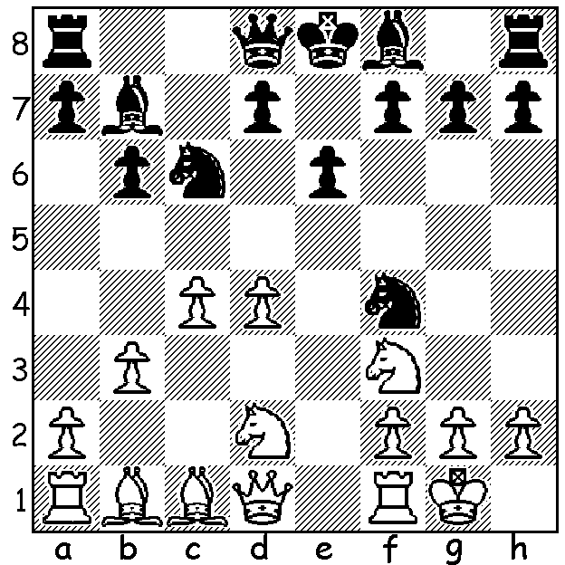

**B. Mazafar vs Wolfgang Leonhardt**

(World Airlines

Championship, Las Vegas)

Black’s next move

shocks White:

**CHESS COLUMNIST RETIRES AFTER 70 YEARS**

I received an email a little while ago from **Wolfgang Leonhardt** highlighting a remarkable chess achievement. **Jim (JJ) Walsh**, at 93-year-old, had announced his retirement after being Chess Correspondent for the Irish Times for almost 70 years, starting on July 21, 1955. He had learnt to play when he was 12 while convalescing in hospital

 after developing tuberculosis (TB). His enthusiasm

for the game impressed the features editor of the

Irish Times who wanted a weekly Chess column to

accompany the Bridge column on the same page. In

2016 Jim became the longest running chess journalist

surpassing the 61 years by Herman Helms at the

Brooklyn Daily Eagle, Jim says that Chess has given

him so much, including meeting his wife-to-be

Maureen through Chess and opportunities to travel

throughout the world. On one trip he went to Moscow

to play and, because so few people travelled behind

the Iron Curtain, he was featured in the Sunday

Dispatch newspaper wearing a heavy overcoat and

fur hat to give the impression the picture had been taken in Moscow. He was much in demand during the Spassky-Fischer World Championship with Jim having to interpret the moves as they came in on telex. His weekly column became a daily puzzle in 1972 and his historic columns continued to feature after his retirement.

Wolfgang, also now well into his nineties (and still playing) was the Chess columnist for the Sunday Times for many years, is a past President of the Chess Association of WA and an eight-times WA champion.

**SOLUTION**: 1…Nxd4!; if 2.Nxd4 Qg5 3.g3 Nh3#. White played 2.Bb2 but lost quickly after 2… Nde2+ 3.Kh1 Qg5! 4.Rg1 Qg4 5.h3 Qh5 6.Be4 Bxe4 7.Nxe4 Nxh3 8.Nh2 Nxf2+! 8.Nxf2 Nge#. A pretty smothered mate.