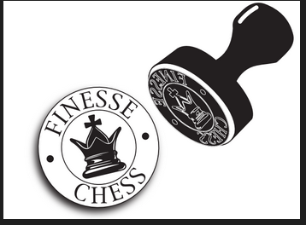

**A Finesse Chess Event**

**2025 Finesse Chess Blitz:**

Saturday 25th January 2025

1:00-5:00

**Proudly supported and presented by Finesse Chess**

***Venue:*** John McGrath Hall – 97 Hensman St, South Perth

***Format:*** 11 Rounds Blitz over two divisions; Open and Amateur

***Time Control:*** 3mins game time + 2 second increment per move

***Round Times:*** Round 1: 1:00-1:15 Round 7: 3:15-3:30

Round 2 1:20-1:35 Round 8: 3:35-3:50

Round 3: 1:40-1:55 Round 9: 3:55-4:10

Round 4: 2:00-2:15 Round 10: 4:15–4:30

Round 5: 2:20-2:35 Round 11. 4:35-4:50

Round 6: 2:40-2:55

**20min break after round 6**

***Closing Date:*** All entries must be received by 6pm Friday 24th January 2025

***Fees:*** $30 Open Division $15 Amateur Division

***Prizes:*** Various prizes based on number of entries

***Arbiter:*** NA Dylan Gough (Finesse Chess Pty Ltd)

***How to Enter:*** Send entries/interest to <https://www.trybooking.com/CWECG>